Multi-Asset Commodity Risk Premia: Research Summary
Metals, Energy, Precious Metals, NGL, Agriculture, Correlation Analysis, and Cross-Commodity Portfolio
Basis of all results: daily returns net of 5 bp round-trip transaction costs, 1 January 2012 to 23 September 2026. Return is the annualised compound return, Vol the annualised volatility and IR their ratio (no risk-free rate). Each asset class has five sleeves: Momentum, Carry, Carry-Momentum, Value and Skewness (minus the skewness of the product's daily log returns over the past 252 observations; long if negative, short if positive). Equal Weight (EW PORT) averages the five sleeves equally; Inverse Vol weights each sleeve by the inverse of its trailing 63-day volatility, lagged one day. Periods (regimes): P1 2012-2016, P2 2017-2021, P3 2022-2026. Each product uses a short and a long tenor pair: Carry is the sign of the sum of the two pairs' z-scores (each against its own trailing 252 observations) and Carry-Momentum is the sign of the sum of the two pairs' slope changes over 20 observations (raw, not standardised); if a value is missing the last signal is kept. Signals are those of the main analysis, except that Value starts after 504 observations of F3 (two years), so that NGL Value is live before 2012. Energy includes Natural Gas unless stated. Relative to the previous version (v4_2012) Carry and Carry-Momentum add the two pairs instead of taking a sign vote (which left the position flat whenever the pairs disagreed), so every Carry, Carry-Momentum, portfolio, ranking and cross-commodity figure is re-derived; Momentum, Value and Skewness are unchanged.
Version note (v6, 1 November 2026). Only the Metals and Petroleum sections have been updated in this version, together with Figures 1, 2 and A1 to A10, Tables A1 to A6 and the Metals and Petroleum rows of Tables A23 to A25. They use the data to 30 September 2026 (five further trading days than the rest of the document) and the current bucket definition: Petroleum is WTI, Brent, RBOB and Heating Oil, and Natural Gas has moved to the Power, Emissions and Nat Gas bucket, so there is no Energy ex-NatGas table any more. Everything else (the basis paragraph above, the Key Findings, the Precious Metals, NGL and Agriculture sections, Correlation Analysis, the Cross-Commodity Portfolio, the remaining tables and charts) is unchanged from v5, still ends on 23 September 2026 and still treats Energy as five products including Natural Gas, so the Key Findings and the cross-commodity figures that quote Metals or Energy numbers do not yet match the updated sections.

Key Findings
- NGL is the strongest sleeve in the research: Equal Weight (IR +1.25) and Inverse Vol (IR +1.16) are well ahead of every other asset class (the best of the rest is Energy at +0.76 and +0.78, or +0.85 and +0.89 without Natural Gas), and Momentum, Carry, and Carry-Momentum are each positive in every period, as they are in Energy. Value (IR +0.08) and Skewness (IR +0.06) are the exceptions: Value is negative in P1 (-0.41), and Skewness is negative in P1 (-0.89) and strongly positive in P2 (+0.93).
- Energy's Carry-Momentum is its strongest strategy (IR +0.78) and Value (IR -0.14) is the only core Energy strategy with a negative full-sample IR; excluding Natural Gas improves Momentum, Value and above all Skewness (but lowers Carry and Carry-Momentum) and lifts the Equal Weight portfolio from IR +0.76 to +0.85. Skewness is positive in Energy (IR +0.17, +0.37 without Natural Gas), but mostly because it stayed long oil after the 2020 collapse.
- In Metals, Value is the only strategy with a clear edge (IR +0.38); both portfolio constructions (Equal Weight -0.04, Inverse Vol +0.08) underperform simply holding Value alone, since blending four sleeves with little or no edge dilutes the one signal that works.
- Precious Metals and Agriculture are the two asset classes where portfolio construction fails: neither earns a positive IR (Precious Metals Equal Weight -0.23, Inverse Vol -0.29; Agriculture -0.15 and -0.18), and in Precious Metals every core strategy is net negative full-sample, as they are in Agriculture apart from a flat Carry (IR +0.01). Skewness is the only sleeve with a positive full-sample IR in each, small in Precious Metals (+0.10) and clearer in Agriculture (+0.25); it trims the loss but does not reverse it.
- Skewness is a different kind of premium from the other four. It is positive in Energy, NGL, Precious Metals and Agriculture and negative in Metals, and it is negative in P1 in four of the five asset classes and positive in P3 in four of the five. Its gains in Energy, NGL and Precious Metals are largely long positions held after crashes (the four oil products were long on 89% to 100% of P3 days), consistent with its +0.46 correlation with a passive commodity index, unlike Momentum, Carry and Carry-Momentum.
- Energy-NGL is the most correlated pair of asset classes for all seven series types (EW PORT correlation 0.35) and Metals-Precious Metals the second most correlated under EW PORT (0.12), yet standalone Energy-NGL is the best-performing of the ten pairs (Equal Weight IR +1.23, Inverse Vol +1.21), proving correlation and performance are separate questions.
- The cross-commodity portfolio (each strategy equal-weighted across the five asset classes, then the five strategies combined) delivers Equal Weight IR +0.87 and Inverse Vol IR +0.91 at a volatility of 4.9% and 5.0%, and is positive in every period under both constructions. It is negatively correlated with equity (Equal Weight -0.09, Inverse Vol -0.11) and a traditional 60/40 portfolio (-0.09, -0.11), but with Skewness included it is positively correlated with a passive commodity index (+0.18, +0.15; -0.04 and -0.04 without Skewness), so it diversifies equity and bonds but is no longer free of commodity beta.
- Diversifying across all five asset classes lowers volatility but not risk-adjusted return: the Energy-NGL pair earns more per unit of risk (IR +1.23 and +1.21; +1.28 and +1.30 without Natural Gas) than the five-class book (IR +0.87 and +0.91), at 10.0% volatility against 4.9%, because the extra diversification comes from Metals, Precious Metals and Agriculture, where the core signals earn little or nothing.

Metals
- Momentum (Return -4.8%, Vol 14.7%, Max Drawdown -60.6%, IR -0.33): negative in P1 (IR -0.43) and P3 (-0.58) and roughly flat in P2 (+0.05). The P3 losses are in Lead (-1.17), Zinc (-0.52) and Copper (-0.33), the metals that spiked in 2021-2022 and then reversed sharply, which is the whipsaw a trend signal cannot avoid; only Aluminium made money in P3 (+0.61).
- Carry (Return +1.5%, Vol 12.3%, Max Drawdown -36.5%, IR +0.12) and Carry-Momentum (Return -1.1%, Vol 11.8%, Max Drawdown -57.6%, IR -0.09): both are positive only in P1 (IR +0.43 / +0.76); in P2 Carry is flat (+0.02) and Carry-Momentum negative (-0.57), and in P3 Carry is marginally negative (-0.07) and Carry-Momentum negative (-0.46). The P1 Carry result comes from Aluminium (IR +0.62), Zinc (+0.36) and Lead (+0.36), the three metals whose curves were in persistent contango (average F1-F13 slope of -4.3%, -2.3% and -1.8%, backwardated on only 1%, 3% and 1% of days), the years of large LME stocks, aluminium financing deals and warehouse queues of more than two years (Reuters, LME; at Access World's Vlissingen warehouse the aluminium queue peaked in 2014 at more than two years, Fastmarkets). Copper, whose curve was close to flat (average slope near zero, backwardated on 48% of days), lost (IR -0.29). Contango eased after P1 in Aluminium (average slope -2.6% in P2 and -2.3% in P3) and Zinc moved into backwardation (+1.2% in P2 and +1.2% in P3), but Lead's contango deepened again in P3 (-0.8% in P2, -2.8% in P3).
- Value (Return +4.2%, Vol 10.8%, Max Drawdown -27.3%, IR +0.38): the strongest strategy and the only one with a clear edge, positive in every period (P1 +0.34, P2 +0.08, P3 +0.79). It correlates at -0.50 with Momentum full-sample, the most negative pairing within the asset class and the strongest diversification relationship.
- The P3 Value result (+0.79) comes from the metals that overshot their five-year averages and fell back: Lead (+0.88), Zinc (+0.73) and Aluminium (+0.61). Aluminium peaked at $3,876 on 4 March 2022 in our series (settlement basis; the LME intraday record, about $4,073 in March, followed fears for European smelters under the energy crisis and for Russian supply) and was down to $2,076 by December 2023, and Zinc fell from $4,523 in April 2022 to $2,240 in May 2023. Copper (+0.15) is the exception because, after falling to $7,162 in July 2022, it rose to $14,851 on 22 September 2026, the high of our series (the LME three-month record reported by market sources is about $14,800 to $14,875 on 9 to 10 September), which market reports tie to US tariff turmoil, tight concentrate supply and electrification and data-centre demand.
- Skewness (Return -1.0%, Vol 12.0%, Max Drawdown -38.7%, IR -0.09): no stable edge, negative in P1 (IR -0.23) and P3 (-0.34) and positive in P2 (+0.35). No metal carries a lasting signal: full-sample IRs are Copper 0.00, Aluminium -0.03, Lead +0.03 and Zinc -0.17, and the sign of each metal changes between P1 and P2 (Aluminium +0.45, -0.40, -0.09; Zinc -0.54, +0.46, -0.37). The sleeve is long on 55% of days in Copper, 48% in Zinc, 47% in Lead and only 24% in Aluminium, and the short legs lose in Copper and Zinc (-0.24 and -0.62 in log return) but earn in Lead (+0.33) and Aluminium (+0.06). It correlates at -0.20 with Value and +0.01 with Momentum.
- Portfolio construction: Equal Weight (Return -0.3%, Vol 5.7%, Max Drawdown -25.2%, IR -0.05) and Inverse Vol (Return +0.4%, Vol 5.1%, Max Drawdown -20.4%, IR +0.07) both underperform holding Value alone (Return +4.2%, Vol 10.8%, Max Drawdown -27.3%, IR +0.38) on IR. Inverse Vol has the shallower drawdown and lower volatility of the two, but neither approaches Value's IR. Adding Skewness as a fifth sleeve lowers volatility (Equal Weight 6.6% to 5.7%, Inverse Vol 6.1% to 5.1%) but also lowers the IR (Equal Weight -0.02 to -0.05, Inverse Vol +0.14 to +0.07).
- Individual-metal decomposition: Momentum's blended IR of -0.33 masks a single working metal. Aluminium alone returns IR +0.21, the only positive result among the four, while Copper, Zinc, and Lead are all negative (Lead as low as -0.56). Value shows the opposite pattern, positive in every metal individually (+0.10 to +0.42), with blended volatility of 10.8% well below the roughly 15.9% average held by any one metal alone.
- Why neither construction beats Value: diversification only adds value when it combines more than one genuine edge. Value is the only strategy with a clear edge (IR +0.38); Carry adds little (+0.12) and Momentum (-0.33), Carry-Momentum (-0.09) and Skewness (-0.09) are negative, so blending them with Value dilutes the one real signal in the book instead of diversifying real risk. The same logic applies within a strategy: blending Momentum across metals dilutes Aluminium's one working signal, while blending Value across metals, where every metal carries a positive edge, lifts the IR above the average single metal (+0.38 against +0.27).
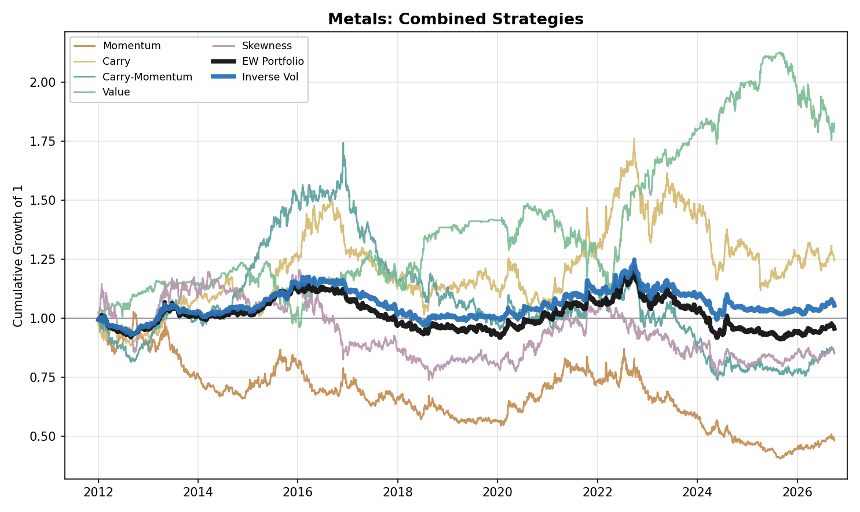
Figure 1. Metals: Combined Strategy Performance (Cumulative Return, 2012-2026)

Petroleum
- Petroleum is the four oil products (WTI, Brent, RBOB gasoline and Heating Oil). It replaces the Energy section of the previous version: Natural Gas has moved to the Power, Emissions and Nat Gas bucket and is not covered here, so the Natural Gas figures and the Energy ex-NatGas comparison are dropped. Figures run to 30 September 2026 (five further trading days, 24 to 30 September, than the previous version).
- Carry-Momentum (Return +19.6%, Vol 27.7%, Max Drawdown -43.2%, IR +0.71) is the strongest individual strategy in Petroleum and, like Momentum and Carry, is positive in every period (Carry-Momentum P1 +0.95, P2 +0.92, P3 +0.34), the clearest evidence in Petroleum that term-structure changes carry information that recurs across periods.
- Momentum (Return +17.5%, Vol 33.1%, Max Drawdown -50.4%, IR +0.53): positive in every period (P1 +0.57, P2 +0.66, P3 +0.36), with most of its return earned in a few large directional moves: calendar years 2014, 2015, 2020 and 2021 account for 87% of its cumulative log return. They coincide with the 2014-2016 price collapse (WTI fell from $107 on 20 June 2014 to $26 on 11 February 2016 in our series, after OPEC's 27 November 2014 decision to hold output against rising US shale supply), the 2020 demand collapse and the 2021 recovery. P3 is its weakest period even though it contains the March 2022 spike to $124 after Russia's invasion of Ukraine (calendar 2022 adds a further 14% of the total). The war between the United States, Israel and Iran that began on 28 February 2026 then disrupted Gulf supply on a scale the IEA calls the largest in the history of the oil market, and Brent futures went from $72 on 27 February to $118 on 31 March; the first nine months of 2026 alone are 24% of the sleeve's cumulative log return.
- Carry (Return +12.2%, Vol 31.0%, Max Drawdown -60.3%, IR +0.39) is positive in every period (P1 +0.45, P2 +0.68, P3 +0.04) but in P3 it is close to flat (IR +0.04), where crude oil is the problem (WTI -0.31, Brent -0.37, against RBOB +0.21 and Heating Oil +0.73) although the curves were the most backwardated of the sample (WTI F1-F3 backwardated on 87% of days in P3 against 24% in P1 and 46% in P2). Carry compares each pair's slope with its own trailing 252-day history, so a high level of backwardation does not by itself produce Carry returns.
- Value (Return -3.3%, Vol 31.0%, Max Drawdown -71.1%, IR -0.11) is the one consistent drag among the four core strategies on a full-sample basis, negative in P1 (IR -0.38) and marginally negative in P3 (-0.03) and marginally positive in P2 (+0.07). The 2014-2016 price collapse (WTI from $107 to $26), triggered by US shale supply growth and OPEC's decision to hold output, behaves as a persistent trend rather than a mean-reverting cycle, exactly the environment a reversion strategy is built to lose in. It correlates at -0.52 with Momentum and -0.53 with Carry, the same diversification relationship seen in Metals (-0.50 with Momentum).
- Skewness (Return +12.0%, Vol 32.6%, Max Drawdown -59.8%, IR +0.37): negative in P1 (IR -0.36) and positive in P2 (+0.57) and P3 (+0.80), and positive in all four products (WTI +0.32, Brent +0.39, RBOB +0.32, Heating Oil +0.24). Its P2 and P3 results are largely one long position. The signal turned long on 11 March 2020 in the middle of the 2020 collapse (the May contract settled at -$37.63 on 20 April, a value our series replaces with an imputed $16.01): the sleeve lost 0.49 in log return in WTI over March and April, then earned +1.21 from May 2020 to December 2021 as prices recovered. The trailing-year skewness of oil returns then stayed negative for years, so the sleeve was long on 99% of P3 days in WTI, 100% in Brent and 100% in RBOB (89% in Heating Oil), and earned the 2022 spike and the 2026 war rally (P3 IR +0.73 in WTI, +0.82 in RBOB). In P1 it was long on 50% of WTI days and lost on those days (-0.76 in log return) as oil fell. Calendar years 2020, 2021, 2022 and 2026 add 2.23 of log return against a full-sample total of 1.67, so the other eleven years net -0.56. It correlates at -0.16 with Momentum, -0.05 with Carry, -0.16 with Carry-Momentum and -0.11 with Value.
- Portfolio construction: Equal Weight (Return +11.3%, Vol 13.4%, Max Drawdown -28.7%, IR +0.84) and Inverse Vol (Return +11.6%, Vol 13.1%, Max Drawdown -26.2%, IR +0.89) are close and both positive in every period (Equal Weight P1 +0.44, P2 +1.43, P3 +0.61; Inverse Vol P1 +0.52, P2 +1.50, P3 +0.62). Unlike Metals, where Inverse Vol lifts the portfolio IR by 0.12, Inverse Vol is ahead of Equal Weight in Petroleum by only 0.04, with slightly lower volatility and a shallower drawdown. Adding Skewness as a fifth sleeve lifts the IR (Equal Weight +0.67 to +0.84, Inverse Vol +0.71 to +0.89) and lowers volatility (Equal Weight 16.6% to 13.4%, Inverse Vol 16.0% to 13.1%), mostly through P2 and P3.
- Individual-product decomposition: Momentum and Carry-Momentum work across WTI, Brent, RBOB, and Heating Oil (IR +0.28 to +0.85), and Carry is positive in every product too (+0.16 to +0.58). Value is negative in three of the four products (IR -0.23 to -0.07) and flat in Brent (+0.02), a broad failure across products rather than one product's loss.
- Physical storage bottlenecks, pipeline capacity limits, and producers' structural need to hedge downside force the market to pay a continuous insurance premium to whoever takes the other side of that risk, the same economic logic that shows up as Carry-Momentum's clean, all-period positive record above. This is an interpretation consistent with the results, not a test of the hedging pressure hypothesis.
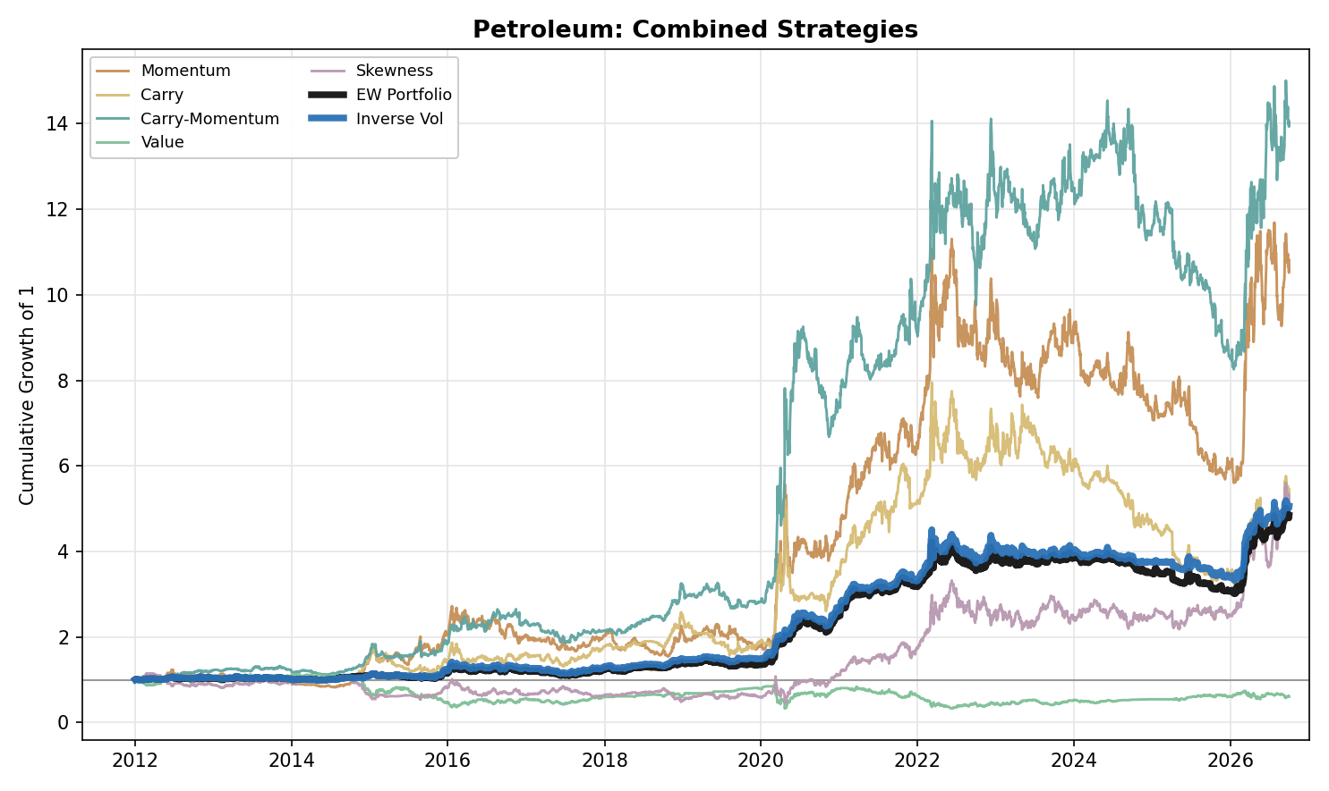
Figure 2. Petroleum: Combined Strategy Performance (Cumulative Return, 2012-2026)

Precious Metals
- Momentum (Return -4.9%, Vol 20.6%, Max Drawdown -73.2%, IR -0.24) is flat in P1 (IR +0.06) and negative in P2 (-0.46) and P3 (-0.29). Precious Metals are priced primarily off macro drivers, above all real yields (the weekly correlation of gold returns with changes in the 10-year real yield, FRED series DFII10, is -0.39 over the sample, -0.64 in P2 and -0.24 in P3), currency-debasement expectations and tail-risk demand, not off their own recent price action, so trend-following has nothing to extract. Gold Momentum earned its two best years in the 2013 sell-off, when gold fell 28% on Fed tapering and ETF outflows (a log return of +0.25), and in the 2025 rally (+0.36), and little otherwise.
- Carry (Return -1.3%, Vol 17.5%, Max Drawdown -41.4%, IR -0.08) and Carry-Momentum (Return -3.7%, Vol 16.1%, Max Drawdown -68.2%, IR -0.23) show no consistent edge: Carry is negative in P1 (IR -0.14) and P2 (-0.09) and flat in P3 (-0.02), while Carry-Momentum is slightly negative in P1 (-0.08), positive in P2 (+0.31) and clearly negative in P3 (-0.75), consistent with the post-2022 higher-real-yield environment pushing Gold and Silver deeper into cost-of-carry contango: the 10-year real yield averaged 1.60% in P3 against 0.03% in P2, and Gold's F1-F7 curve averaged -4.5% in P3 against -1.8% in P2 and -0.6% in P1 (Silver F1-F6 -4.5%, -2.3% and -1.1%).
- The long tenor pair does not change that conclusion. Carry IR: previous single pair (F1-F3) -0.17, short pair F1-F2 -0.25, long pair alone -0.18, two-pair sum -0.08. Carry-Momentum IR: previous single pair -0.30, short pair -0.21, long pair alone +0.04, two-pair sum -0.23.
- Value (Return -1.1%, Vol 17.9%, Max Drawdown -55.2%, IR -0.06) carries no full-sample edge, and the pattern is mixed at the product level: Platinum is the only metal with a positive signal (IR +0.11), Silver (-0.06) and Palladium (-0.03) are flat, and Gold (-0.23) is negative. Gold's loss is a P3 loss (-0.61): Value shorts a metal that trades more than 10% above its five-year average, and gold rose from $1,662 at the end of September 2022 to $4,341 at the end of 2025, with central banks buying 863 tonnes in 2025 against a 2010-2021 annual average of 473 tonnes (World Gold Council). Gold's Value position lost 0.45 in log return in 2025 alone.
- Skewness (Return +2.1%, Vol 20.3%, Max Drawdown -40.4%, IR +0.10) is the only sleeve in this asset class with a positive full-sample IR, and it is small. It is negative in P1 (IR -0.26) and positive in P2 (+0.25) and P3 (+0.26). Silver is the best metal (IR +0.15; Gold +0.02, Platinum +0.07, Palladium +0.03). The P3 result comes from long positions: the sleeve was long on 71% of P3 days in Gold and 57% in Silver, and the long legs earned +0.51 and +0.91 in log return, concentrated in 2025 (sleeve log return Gold +0.45, Silver +0.83), when gold rose to $4,341 by the end of the year, and for Silver also in 2026 (+0.52 to 23 September), after a loss of 0.31 in 2022. It correlates at -0.62 with Value, the strongest negative pairing in the asset class, consistent with Value shorting the metals that have rallied while Skewness stays long them, and at +0.20 with Carry.
- Portfolio construction: Equal Weight (Return -1.8%, Vol 7.8%, Max Drawdown -35.7%, IR -0.23) and Inverse Vol (Return -2.3%, Vol 7.7%, Max Drawdown -39.1%, IR -0.29) are both net negative full-sample and in every period (P1 -0.20 / -0.38, P2 -0.04 / -0.11, P3 -0.40 / -0.39). Skewness trims the loss (Equal Weight -0.31 to -0.23, Inverse Vol -0.36 to -0.29) but does not turn it positive. Precious Metals is, with Agriculture, one of the two asset classes where no core strategy earns a worthwhile IR (here every core strategy is net negative full-sample) and neither construction earns a positive IR.
- Individual-metal decomposition: Momentum has no edge in any metal (Gold +0.03, Silver -0.05, Platinum -0.15, Palladium -0.37). Carry is near zero or slightly positive in Gold (+0.01), Silver (+0.16) and Platinum (+0.06); its negative blended IR comes from Palladium (-0.31), which is also the weakest metal for Momentum (-0.37) and Carry-Momentum (-0.28). Value's only positive edge sits in Platinum (IR +0.11).
- Fundamentally, gold producers hedge little (the global producer hedge book was 218 tonnes in Q3 2017 and under 200 tonnes by the end of 2024, 182 tonnes on the World Gold Council's first estimate and about 194 tonnes after later revisions), so there are few commercial hedgers paying an insurance premium to transfer downside risk to financial counterparties; without that premium, Momentum has no structural engine to harvest here.
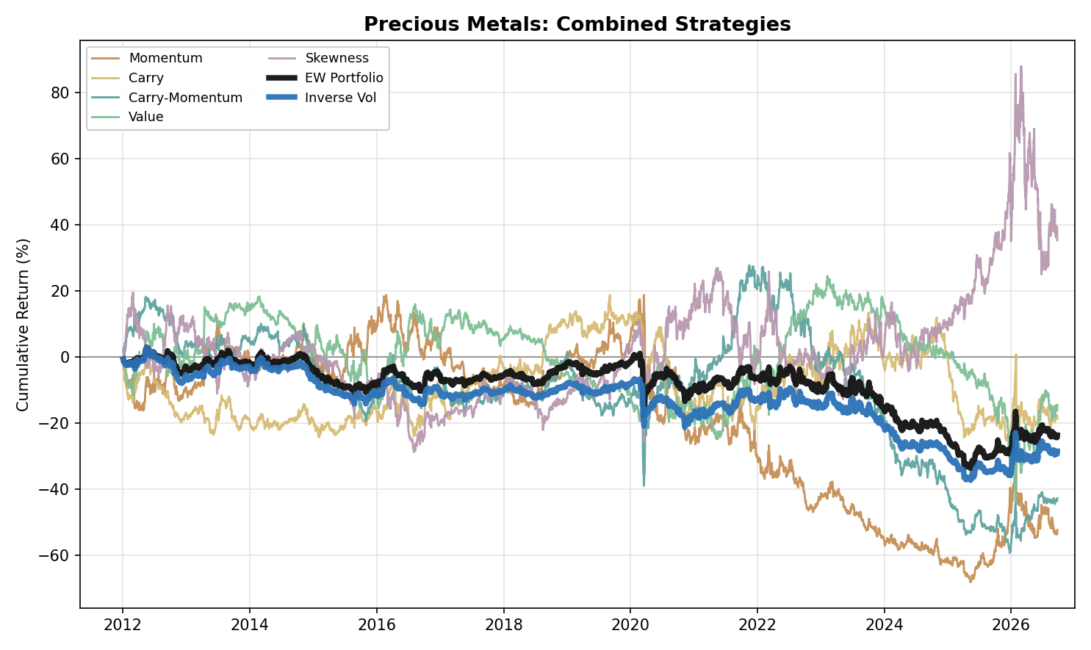
Figure 3. Precious Metals: Combined Strategy Performance (Cumulative Return, 2012-2026)

NGL
- NGL is the strongest sleeve in the research: Equal Weight (Return +15.7%, Vol 12.5%, Max Drawdown -20.9%, IR +1.25) and Inverse Vol (Return +14.2%, Vol 12.3%, Max Drawdown -21.5%, IR +1.16), the best full-sample IR of any asset class under both constructions. At the individual-strategy level, Momentum (IR +1.13), Carry (IR +1.08) and Carry-Momentum (IR +0.71) are positive in every one of the three periods. Value (Return +2.2%, Vol 26.7%, Max Drawdown -72.2%, IR +0.08) is an exception: net positive full-sample but negative in P1 (-0.41), flat in P2 (+0.05) and strongly positive in P3 (+0.87). Skewness (Return +1.7%, Vol 27.2%, Max Drawdown -82.9%, IR +0.06) is the other: negative in P1 (-0.89), strongly positive in P2 (+0.93) and weakly positive in P3 (+0.12).
- NGL's portfolios are strong in every period rather than in one: Equal Weight IR is P1 +0.66, P2 +1.99, P3 +1.00 and Inverse Vol P1 +0.53, P2 +1.83, P3 +1.00. Both are well ahead of every other asset class, whose best full-sample Equal Weight IR is +0.76 (Energy; +0.85 without Natural Gas). Skewness shifts the profile within the periods: P1 falls from +1.15 to +0.66 for Equal Weight and P2 rises from +1.58 to +1.99, while the full-sample IR barely moves (+1.27 to +1.25; Inverse Vol +1.19 to +1.16) and volatility falls (15.4% to 12.5%). The macro backdrop is the US export build-out: in 2012 Mont Belvieu propane traded at an average $0.89/gal discount to international prices because export terminals were at capacity (EIA), and US propane exports averaged a record 1.8 million b/d in 2024 (EIA) and reached a record 2.1 million b/d in April 2026 (EIA; exports first topped 2 million b/d in November 2024), while ethane exports reached 492,000 b/d in 2024 against 65,000 b/d in 2015 and normal butane 491,000 b/d against 97,000 (OPIS, citing EIA).
- Carry (Return +28.2%, Vol 26.1%, Max Drawdown -46.5%, IR +1.08) is the clearest embodiment of NGL's seasonal mechanics: predictable weather- and industrial-driven demand cycles push futures curves from contango in low-demand build periods into steep backwardation as inventories drain in peak season. In the data the F2-F4 slope, averaged over the four products, is +3.7% (backwardation) in December to March and -1.7% (contango) in June to September. Carry is positive in every period (IR +0.48 to +1.45), capturing that swing.
- The two portfolio constructions are close, with Equal Weight ahead on return, IR and drawdown: Equal Weight returns +15.7% against +14.2% for Inverse Vol, with an IR of +1.25 against +1.16 and a maximum drawdown of -20.9% against -21.5%, while Inverse Vol has marginally lower volatility (12.3% against 12.5%).
- The P3 Value result (+0.87) is not a one-year event: the sleeve earns a positive log return in each of 2022 to 2026, and 2026 is its best year of the period (+0.36, against +0.09 in 2025). It is led by Propane (+1.47) and Butane (+1.09). The war that began on 28 February 2026 and the closure of the Strait of Hormuz disrupted around 30% of global LPG supply (Veson Nautical estimate) and sent US LPG exports to a record 3.3 million b/d in April 2026 (S&P Global); in our series the Propane contract held by the strategy (rolled on the fifth trading day of its expiry month) rose from $0.67/gal on 27 February to $0.90/gal on 27 March.
- Skewness is a single-regime result in NGL. It is negative in all four products in P1 (IR -0.26 to -0.81) and positive in all four in P2 (IR +0.16 to +1.82); by calendar year it loses 0.66 in 2012 and earns +1.09 in 2020 and +0.55 in 2021, the crash and recovery of 2020-2021: the sleeve was short into the collapse (all four products had been short since mid-February; Ethane's position earned +0.46 short and +0.64 long in March and April 2020, turning long on 20 March) and in the other three products turned long on 11 March 2020, earning +1.51 in Propane, +1.46 in Butane and +1.37 in Isobutane from May 2020 to December 2021, then stayed long (79% or more of P3 days in every product); it adds +0.39 in 2026. It correlates at -0.25 with Momentum and -0.31 with Carry, the most negative pairings in any asset class for those two, and at +0.27 with Value.
- Individual-product decomposition: Momentum works uniformly across all four products (IR +0.67 to +1.10), the highest weakest-product result of any strategy in any asset class in the research. Carry (IR +0.26 to +0.98) and Carry-Momentum (IR +0.16 to +0.86) are also positive in every product. Value's modest full-sample edge is concentrated in Butane and Isobutane (IR +0.26 / +0.17), while Ethane and Propane show none (IR -0.10 / +0.01); the period inconsistency above is clearest in Propane (IR -0.34 in P1, -0.42 in P2, +1.47 in P3). Skewness is positive in Ethane (+0.27), about flat in Isobutane (+0.05) and slightly negative in Propane (-0.08) and Butane (-0.08).
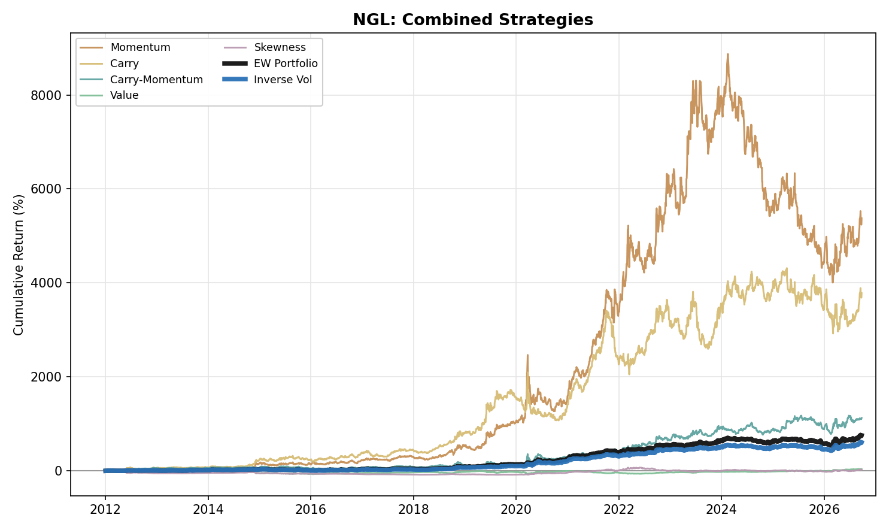
Figure 4. NGL: Combined Strategy Performance (Cumulative Return, 2012-2026)

Agriculture
- Agriculture (six products: Corn, Wheat, Soybean, Soybean Oil, Coffee, Sugar) has no edge in any of the four core sleeves: Momentum (-0.12), Carry-Momentum (-0.34) and Value (-0.10) are net negative full-sample and Carry is flat (+0.01), and Equal Weight (Return -0.8%, Vol 5.5%, Max Drawdown -26.5%, IR -0.15) and Inverse Vol (Return -0.9%, Vol 5.4%, Max Drawdown -24.2%, IR -0.18) follow. Skewness (Return +2.7%, Vol 11.1%, Max Drawdown -31.0%, IR +0.25) is the only sleeve with a worthwhile positive full-sample IR. Together with Precious Metals it is one of the two asset classes where neither portfolio construction earns a positive IR.
- Momentum (Return -1.6%, Vol 12.8%, Max Drawdown -47.7%, IR -0.12) is negative in P1 (IR -0.16) and P3 (-0.31) and marginally positive in P2 (+0.11). By product it is negative in Corn (-0.25), Wheat (-0.22), Soybean (-0.09) and Sugar (-0.07) and only modestly positive in Soybean Oil (+0.12) and Coffee (+0.12).
- Carry (Return +0.1%, Vol 11.6%, Max Drawdown -30.1%, IR +0.01) and Carry-Momentum (Return -4.0%, Vol 11.7%, Max Drawdown -53.4%, IR -0.34) are negative in P1 (Carry -0.13, Carry-Momentum -0.23), positive in P2 (+0.47 / +0.07) and at their worst in P3 (-0.34 / -0.85). Coffee is the swing: Carry-Momentum in Coffee returns IR +0.88 in P2, when the July 2021 Brazilian frosts lifted arabica by 34% in a week in our series (19 to 26 July) to its highest front-month price since October 2014 (Reuters, Bloomberg), and -0.64 in P3 (Carry -0.61), after the price reached its high of $4.39/lb in our series on 13 February 2025 (our series is the front-month, March, contract; the most active contract set its record at about $4.30 that month) and fell back to $2.76/lb by 23 September 2026 in our series.
- The long tenor pair matters differently for the two sleeves. Carry IR: short pair alone (F1-F2) -0.23, long pair alone +0.14, two-pair sum +0.01. Carry-Momentum IR: short pair alone +0.03, long pair alone -0.20, two-pair sum -0.34. The sum improves on the short pair for Carry but not for Carry-Momentum, and neither sum beats the better single pair.
- Value (Return -1.3%, Vol 12.9%, Max Drawdown -47.9%, IR -0.10) is flat to negative: flat in P1 (IR -0.01), negative in P2 (-0.24) and slightly negative in P3 (-0.07). Corn is the weakest product in P1, where the class is flat only because Coffee offsets it (Coffee Value IR +0.58): Corn Value has an IR of -0.50 in P1 and loses in every year from 2012 to 2016 (log returns of -0.03, -0.20, -0.05, -0.19, -0.12), starting with the 2012 US drought that pushed corn to a record, with USDA projecting record season-average prices of $7.50 to $8.90 per bushel in August 2012. Value shorts a market that trades more than 10% above its five-year average.
- Skewness (Return +2.7%, Vol 11.1%, Max Drawdown -31.0%, IR +0.25) is the one clearly positive sleeve: IR +0.32 in P1, -0.19 in P2 and +0.56 in P3. It works in four of the six products (Soybean Oil +0.41, Soybean +0.36, Corn +0.28, Wheat +0.21) and is negative in Coffee (-0.28) and Sugar (-0.08). The clearest case is Wheat: its returns are spike-prone (the 2012 drought, the 2022 invasion of Ukraine), so its trailing-year skewness is positive most of the time and the sleeve is short on 86% of days; that short leg earns +1.01 in log return over the sample, including +0.55 in P3 as Wheat fell from $14.25 on 7 March 2022 to $7.09. In 2022 Corn, Soybean Oil and Soybean add +0.50, +0.46 and +0.37 in log return, and Wheat adds +0.36 in 2023 as it fell. In Coffee, where the 2021 frost and the 2025 record were followed by sharp reversals, the signal loses on both legs (long leg -0.72, short leg -0.70). It correlates at -0.04 with Momentum, -0.04 with Carry, -0.08 with Carry-Momentum and -0.14 with Value.
- Portfolio construction: Equal Weight is slightly negative in P1 (-0.09) and positive in P2 (+0.11), and Inverse Vol is negative in P1 (-0.26) and marginally positive in P2 (+0.05); both are clearly negative in P3 (-0.44 / -0.29), and the P3 losses are the main drag on the full-sample result (Inverse Vol also loses in P1). Skewness trims them (P3 Equal Weight -0.69 to -0.44, Inverse Vol -0.59 to -0.29; full-sample Equal Weight -0.26 to -0.15, Inverse Vol -0.27 to -0.18). P3 opens with the Russia-Ukraine price spike and its reversal: Wheat peaked at $14.25/bu on 7 March 2022 and was $7.09 by 23 September 2026, Corn went from $8.18 on 29 April 2022 to $5.29 and Soybean Oil from 90.6 cents/lb on 28 April 2022 to 67.3, while the FAO food price index peaked in March 2022 (159.3 points, the highest since 1990) and its 2023 average was 13.7% below 2022. Sharp spikes followed by reversals, in grains in 2022 and in coffee in 2024-2025, are the pattern signals built on trend and curve slope handle worst.
- Individual-product decomposition: no core sleeve works across the six products. The best single core product-sleeve result is Soybean Oil Carry (IR +0.22) and the three weakest are Wheat Carry-Momentum (-0.53), Corn Value (-0.30) and Corn Momentum (-0.25); no core product-sleeve result is above +0.22. The best results overall are Skewness in Soybean Oil (+0.41) and Soybean (+0.36).
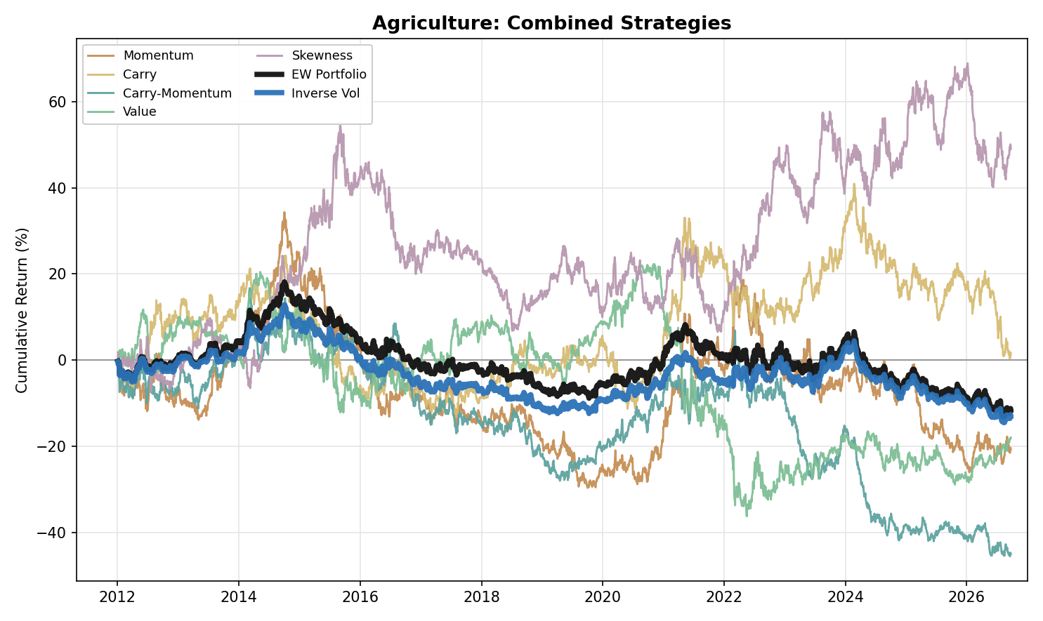
Figure 5. Agriculture: Combined Strategy Performance (Cumulative Return, 2012-2026)

Correlation Analysis

Within-Asset-Class Correlation
- Value is the least correlated sleeve with its own EW PORT in every asset class, correlating at -0.07 in Metals, -0.21 in Energy, +0.12 in NGL, -0.29 in Precious Metals and +0.13 in Agriculture. Skewness is the second least correlated in every class (+0.36 in Metals, +0.27 in Energy, +0.26 in NGL, +0.40 in Precious Metals and +0.27 in Agriculture), so the two sleeves with the weakest links to the portfolio are the two that are not built on trend or curve slope, which is consistent with, not a test of, their acting as diversifiers. In NGL and Agriculture, where Value is positively correlated with the portfolio, it is still the lowest of the five.
- Momentum and Carry are the most correlated pair of base strategies in Energy (+0.67), NGL (+0.68) and Agriculture (+0.40), consistent with a common driver behind the two signals (not tested here). Metals and Precious Metals each break this pattern: in both, Carry and Carry-Momentum are the closest pair (+0.41 in Metals, +0.50 in Precious Metals). Value is negatively correlated with Momentum in all five asset classes (-0.50 Metals, -0.49 Energy, -0.46 NGL, -0.41 Precious Metals and -0.29 Agriculture).
- Skewness pairs differently by asset class. With Value it is negative in four classes and strongest in Precious Metals (-0.20 in Metals, -0.15 in Energy, +0.27 in NGL, -0.62 in Precious Metals and -0.14 in Agriculture); in Precious Metals the two sleeves tend to hold opposite positions (daily position correlation -0.81 in Palladium and -0.33 in Gold): Value is short when a metal trades well above its long-run average, and Skewness is then long on 67% to 99% of those days across the four metals, consistent with Value shorting rallies that Skewness stays long. With Momentum and Carry it is mostly near zero or mildly negative, and most negative in NGL (-0.25 and -0.31); in Precious Metals it is positive with Carry (+0.20).
- Inverse Vol tracks its own EW PORT closely everywhere, correlating between 0.95 and 0.99 across all five asset classes, expected since both portfolios are built from the same five sleeves and differ only in how they are weighted.

Cross-Commodity Correlation
- Energy and NGL are the most correlated cross-commodity pair for all seven series types tracked: Momentum (0.46), Carry (0.26), Carry-Momentum (0.21), Value (0.55), Skewness (0.51), EW PORT (0.35) and Inverse Vol (0.34), consistent with both trading the same hydrocarbon complex.
- Metals-Precious Metals is the second most correlated pair for Momentum (0.23), Value (0.27), Skewness (0.15), EW PORT (0.12) and Inverse Vol (0.10), a link between the two metal groups that is not explained here. For the other two series the second-place pairs are weaker still (second place is Metals-NGL for Carry at 0.09 and Energy-Agriculture for Carry-Momentum at 0.06), and Metals-Precious Metals is essentially uncorrelated for Carry-Momentum (+0.01).
- Carry-Momentum has the lowest cross-commodity correlations of the seven series: its correlations to the same strategy in other asset classes average just 0.05 in magnitude (Carry 0.07; the other five range 0.08 to 0.20), and none of its ten pairwise readings exceeds 0.21.

Portfolio Construction Implication
- The Cross-Pair tab shows all ten asset-class pairs. Under the EW PORT measure, Energy-NGL (0.35) and Metals-Precious Metals (0.12) are the two most correlated pairs; every other pair is at or below 0.08. The table below sets each pair's EW PORT correlation beside its full-sample IR under Equal Weight and Inverse Vol (Energy including Natural Gas).
Pair | EW PORT correlation | Equal Weight IR | Inverse Vol IR
Energy-NGL | 0.35 | +1.23 | +1.21
Metals-NGL | 0.06 | +1.07 | +0.85
NGL-Agriculture | 0.06 | +1.02 | +0.72
Precious Metals-NGL | 0.02 | +0.89 | +0.61
Metals-Energy | 0.06 | +0.65 | +0.57
Energy-Agriculture | 0.08 | +0.59 | +0.38
Energy-Precious Metals | 0.03 | +0.48 | +0.38
Metals-Agriculture | 0.03 | -0.13 | -0.09
Metals-Precious Metals | 0.12 | -0.20 | -0.13
Precious Metals-Agriculture | 0.04 | -0.27 | -0.41

- Correlation and standalone performance are separate questions. Held on its own, Energy-NGL, the most correlated pair, produces the highest full-sample IR of the ten pairs under both constructions (Equal Weight +1.23, Inverse Vol +1.21), while Precious Metals-Agriculture produces the lowest under both constructions (Equal Weight -0.27, Inverse Vol -0.41). Two individually strong books can still make a poor diversification pairing simply because they move together.

Cross-Commodity Portfolio
- Diversifying each individual strategy across all five asset classes first (equal-weighted), then combining strategies, lifts every strategy above its worst individual asset-class showing: Momentum (Return +6.1%, Vol 12.5%, Max Drawdown -36.0%, IR +0.49), Carry (Return +7.9%, Vol 10.1%, Max Drawdown -23.4%, IR +0.78), Carry-Momentum (Return +5.3%, Vol 9.2%, Max Drawdown -27.8%, IR +0.58), Value (Return 0.0%, Vol 12.1%, Max Drawdown -44.6%, IR 0.00) and Skewness (Return +2.1%, Vol 11.8%, Max Drawdown -44.0%, IR +0.18). The worst asset-class IRs for the same strategies are -0.32, -0.08, -0.34, -0.14 and -0.08.
- At the top level, combining those five cross-commodity strategies gives Equal Weight (Return +4.2%, Vol 4.9%, Max Drawdown -13.7%, IR +0.87) and Inverse Vol (Return +4.5%, Vol 5.0%, Max Drawdown -12.7%, IR +0.91). Inverse Vol is the stronger construction, with the higher return and IR and the shallower drawdown at nearly the same volatility.
- The cross-commodity book is positive in every one of the three periods under both constructions (Equal Weight P1 +0.59, P2 +1.65, P3 +0.39; Inverse Vol P1 +0.75, P2 +1.57, P3 +0.47). Among the single asset classes only Energy and NGL do the same, and both do so at more than twice the cross-commodity volatility (Equal Weight 11.8% and 12.5% against 4.9%).
- The weakest period for the cross-commodity book is P3 (Equal Weight IR +0.39, Inverse Vol +0.47), still positive but a fraction of the strength shown in P2. Within the strategies, P3 is the period in which Momentum turns negative (-0.07) while Carry (+0.21) and Carry-Momentum (+0.08) are only modestly positive; Skewness (+0.46) and Value (+0.30) are the best sleeves, and Skewness is also the weakest in P1 (-0.79).
- Skewness changes the book in three ways. It lifts the full-sample IR (Equal Weight +0.79 to +0.87, Inverse Vol +0.86 to +0.91) and cuts volatility (Equal Weight 6.0% to 4.9%) and maximum drawdown (-18.5% to -13.7%); it moves the IR from P1 to P3 (Equal Weight P1 +0.91 to +0.59, P3 +0.21 to +0.39); and it adds commodity beta (see the benchmark correlations below).
- Excluding Natural Gas from Energy lifts the book to Equal Weight (Return +4.7%, Vol 5.1%, Max Drawdown -14.8%, IR +0.92) and Inverse Vol (Return +4.9%, Vol 5.2%, Max Drawdown -14.0%, IR +0.95). Combining in the opposite order, each asset class's five sleeves first and then the five asset-class portfolios, gives the identical Equal Weight result (IR +0.87); the three other weighting combinations give IRs of +0.66, +0.85 and +0.60 (sleeves Equal Weight / across Inverse Vol; sleeves Inverse Vol / across Equal Weight; Inverse Vol at both stages).
- Across all ten asset-class pairings, Energy-NGL is the best-performing combination under both constructions (Equal Weight +1.23, Inverse Vol +1.21; +1.28 and +1.30 without Natural Gas) even though it is the most correlated pair, and it beats the five-class book on IR (Equal Weight +0.87, Inverse Vol +0.91) at 10.0% volatility against 4.9%. The only pairs with a negative full-sample IR under either construction are the three built from Metals, Precious Metals and Agriculture alone: Metals-Precious Metals (-0.20 / -0.13), Metals-Agriculture (-0.13 / -0.09) and Precious Metals-Agriculture (-0.27 / -0.41), and each is clearly negative in P3 under both constructions (Equal Weight -0.48, -0.53, -0.56; Inverse Vol -0.41, -0.36, -0.67), consistent with those three asset classes' own EW PORT IRs of -0.04, -0.23 and -0.15. Energy-NGL is the most construction-robust pair (Equal Weight +1.23, Inverse Vol +1.21), while Inverse Vol's effect is otherwise uneven: it pulls down NGL-Agriculture most (+1.02 to +0.72), consistent with inverse-vol weighting reducing the weight on NGL's higher-volatility portfolio (12.5% against 5.5% for Agriculture). Replacing Energy with Energy ex-NatGas lifts all four Energy pairs under Equal Weight.
- Benchmarked against traditional assets, the five-sleeve cross-commodity book still diversifies equity and bonds but is no longer free of commodity beta: it correlates negatively with Equity (Equal Weight -0.09, Inverse Vol -0.11) and with a traditional 60/40 portfolio (-0.09, -0.11), stays close to zero against Fixed Income (-0.05, -0.05) and Gold (+0.02, +0.02), but is positively correlated with a passive Commodity Index (+0.18, +0.15; -0.04 and -0.04 without Skewness). The change comes from Skewness, which correlates +0.46 with the Commodity Index, +0.17 with Equity and +0.17 with Gold, consistent with the sleeve being long-biased after price falls (the four oil products were long on 89% to 100% of P3 days and the four NGL products on 79% to 99%). Momentum, Carry and Carry-Momentum remain negatively correlated with Equity and essentially uncorrelated with Gold (+0.01, -0.02, +0.01); Value (+0.14) and Skewness are the two strategies positively correlated with Equity. The correlations use daily returns of the SPY, AGG, DBC and GLD ETFs (adjusted prices from Yahoo Finance, downloaded 12 October 2026) on the days they share with the strategy series, from 2012 to 23 September 2026. Full detail in the Appendix.
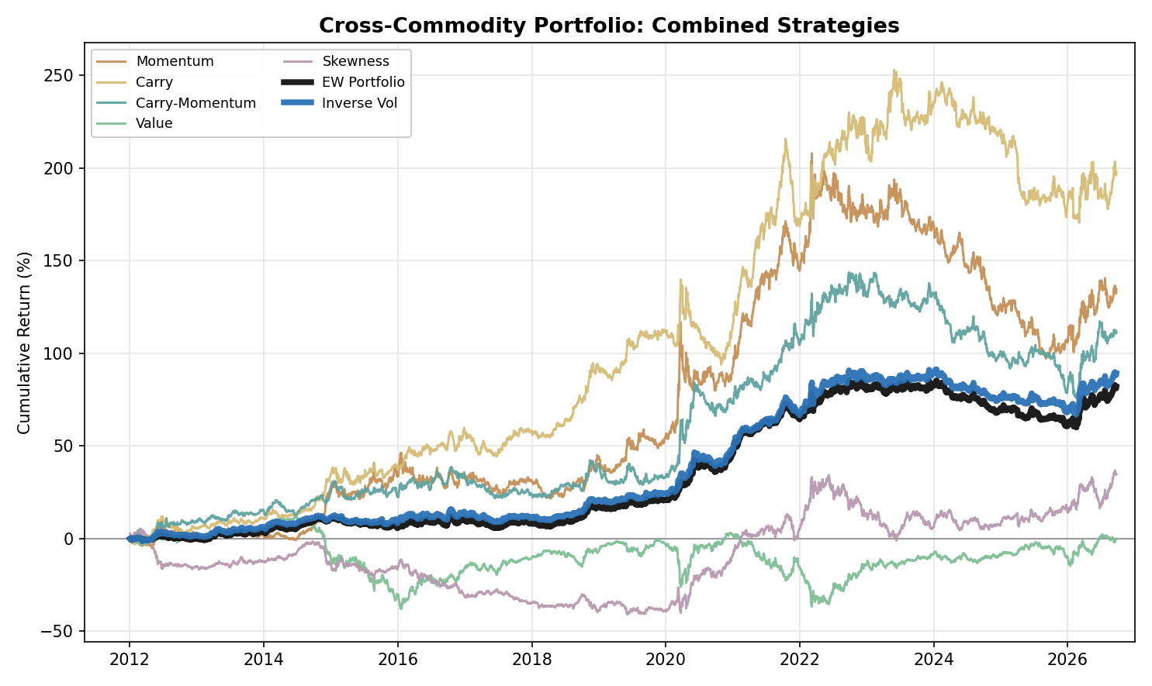
Figure 6. Cross-Commodity Portfolio: Combined Strategy Performance (Cumulative Return, 2012-2026)

Appendix: Period-Level Detail
Table A1. Metals: Strategy Information Ratios by Period
 | Full | 2012-16 | 2017-21 | 2022-26
Momentum | -0.33 | -0.43 | +0.05 | -0.58
Carry | +0.12 | +0.43 | +0.02 | -0.07
Carry-Momentum | -0.09 | +0.76 | -0.57 | -0.46
Value | +0.38 | +0.34 | +0.08 | +0.79
Skewness | -0.09 | -0.23 | +0.35 | -0.34

Table A2. Metals: Portfolio Construction Information Ratios by Period
 | Full | 2012-16 | 2017-21 | 2022-26
Equal Weight | -0.05 | +0.27 | -0.05 | -0.35
Inverse Vol | +0.07 | +0.48 | -0.02 | -0.19

Table A3. Metals: Individual-Metal Information Ratios, All Strategies (Full Sample)
 | Copper | Aluminium | Lead | Zinc
Momentum | -0.31 | +0.21 | -0.56 | -0.17
Carry | +0.13 | +0.26 | -0.19 | +0.11
Carry-Momentum | +0.05 | +0.03 | -0.24 | -0.02
Value | +0.10 | +0.16 | +0.42 | +0.38
Skewness | 0.00 | -0.03 | +0.03 | -0.17

Table A4. Petroleum: Strategy Information Ratios by Period
 | Full | 2012-16 | 2017-21 | 2022-26
Momentum | +0.53 | +0.57 | +0.66 | +0.36
Carry | +0.39 | +0.45 | +0.68 | +0.04
Carry-Momentum | +0.71 | +0.95 | +0.92 | +0.34
Value | -0.11 | -0.38 | +0.07 | -0.03
Skewness | +0.37 | -0.36 | +0.57 | +0.80

Table A5. Petroleum: Portfolio Construction Information Ratios by Period
 | Full | 2012-16 | 2017-21 | 2022-26
Equal Weight | +0.84 | +0.44 | +1.43 | +0.61
Inverse Vol | +0.89 | +0.52 | +1.50 | +0.62

Table A6. Petroleum: Individual-Product Information Ratios, All Strategies (Full Sample)
 | WTI | Brent | RBOB | Heating Oil
Momentum | +0.49 | +0.42 | +0.28 | +0.65
Carry | +0.16 | +0.27 | +0.32 | +0.58
Carry-Momentum | +0.85 | +0.48 | +0.35 | +0.32
Value | -0.07 | +0.02 | -0.12 | -0.23
Skewness | +0.32 | +0.39 | +0.32 | +0.24

Table A7. Precious Metals: Strategy Information Ratios by Period
 | Full | 2012-16 | 2017-21 | 2022-26
Momentum | -0.24 | +0.06 | -0.46 | -0.29
Carry | -0.08 | -0.14 | -0.09 | -0.02
Carry-Momentum | -0.23 | -0.08 | +0.31 | -0.75
Value | -0.06 | +0.05 | -0.07 | -0.13
Skewness | +0.10 | -0.26 | +0.25 | +0.26

Table A8. Precious Metals: Portfolio Construction Information Ratios by Period
 | Full | 2012-16 | 2017-21 | 2022-26
Equal Weight | -0.23 | -0.20 | -0.04 | -0.40
Inverse Vol | -0.29 | -0.38 | -0.11 | -0.39

Table A9. Precious Metals: Individual-Metal Information Ratios, All Strategies (Full Sample)
 | Gold | Silver | Platinum | Palladium
Momentum | +0.03 | -0.05 | -0.15 | -0.37
Carry | +0.01 | +0.16 | +0.06 | -0.31
Carry-Momentum | -0.13 | -0.05 | -0.02 | -0.28
Value | -0.23 | -0.06 | +0.11 | -0.03
Skewness | +0.02 | +0.15 | +0.07 | +0.03

Table A10. Precious Metals: Carry Tenor Pairs, Full-Sample Information Ratios
 | Previous single pair (F1-F3) | Short pair (F1-F2) | Long pair alone | Two-pair sum
Carry | -0.17 | -0.25 | -0.18 | -0.08
Carry-Momentum | -0.30 | -0.21 | +0.04 | -0.23

Table A11. NGL: Strategy Information Ratios by Period
 | Full | 2012-16 | 2017-21 | 2022-26
Momentum | +1.13 | +1.06 | +1.87 | +0.41
Carry | +1.08 | +1.45 | +1.28 | +0.48
Carry-Momentum | +0.71 | +0.54 | +0.73 | +0.93
Value | +0.08 | -0.41 | +0.05 | +0.87
Skewness | +0.06 | -0.89 | +0.93 | +0.12

Table A12. NGL: Portfolio Construction Information Ratios by Period
 | Full | 2012-16 | 2017-21 | 2022-26
Equal Weight | +1.25 | +0.66 | +1.99 | +1.00
Inverse Vol | +1.16 | +0.53 | +1.83 | +1.00

Table A13. NGL: Individual-Product Information Ratios, All Strategies (Full Sample)
 | Ethane | Propane | Butane | Isobutane
Momentum | +0.82 | +0.67 | +1.10 | +0.73
Carry | +0.26 | +0.97 | +0.92 | +0.98
Carry-Momentum | +0.16 | +0.86 | +0.52 | +0.52
Value | -0.10 | +0.01 | +0.26 | +0.17
Skewness | +0.27 | -0.08 | -0.08 | +0.05

Table A14. Agriculture: Strategy Information Ratios by Period
 | Full | 2012-16 | 2017-21 | 2022-26
Momentum | -0.12 | -0.16 | +0.11 | -0.31
Carry | +0.01 | -0.13 | +0.47 | -0.34
Carry-Momentum | -0.34 | -0.23 | +0.07 | -0.85
Value | -0.10 | -0.01 | -0.24 | -0.07
Skewness | +0.25 | +0.32 | -0.19 | +0.56

Table A15. Agriculture: Portfolio Construction Information Ratios by Period
 | Full | 2012-16 | 2017-21 | 2022-26
Equal Weight | -0.15 | -0.09 | +0.11 | -0.44
Inverse Vol | -0.18 | -0.26 | +0.05 | -0.29

Table A16. Agriculture: Individual-Product Information Ratios, All Strategies (Full Sample)
 | Corn | Wheat | Soybean | Soybean Oil | Coffee | Sugar
Momentum | -0.25 | -0.22 | -0.09 | +0.12 | +0.12 | -0.07
Carry | -0.10 | -0.06 | -0.14 | +0.22 | +0.12 | -0.06
Carry-Momentum | -0.18 | -0.53 | -0.07 | -0.16 | +0.10 | -0.04
Value | -0.30 | +0.09 | -0.11 | -0.08 | 0.00 | -0.02
Skewness | +0.28 | +0.21 | +0.36 | +0.41 | -0.28 | -0.08

Table A17. Agriculture: Carry Tenor Pairs, Full-Sample Information Ratios
 | Previous single pair (F1-F2) | Long pair alone | Two-pair sum
Carry | -0.23 | +0.14 | +0.01
Carry-Momentum | +0.03 | -0.20 | -0.34

Table A18. Cross-Commodity Portfolio: Correlation vs Traditional Assets (2012 to 23 September 2026)
 | Equity | Fixed Income | Commodity Index | Gold | 60/40 Portfolio
Momentum | -0.22 | -0.03 | -0.10 | +0.01 | -0.22
Carry | -0.17 | -0.05 | -0.01 | -0.02 | -0.17
Carry-Momentum | -0.14 | -0.03 | -0.06 | +0.01 | -0.14
Value | +0.14 | +0.02 | +0.07 | -0.12 | +0.13
Skewness | +0.17 | -0.02 | +0.46 | +0.17 | +0.16
EW Portfolio | -0.09 | -0.05 | +0.18 | +0.02 | -0.09
Inverse Vol | -0.11 | -0.05 | +0.15 | +0.02 | -0.11

Table A19. Cross-Commodity Portfolio: Strategy Information Ratios by Period (all 5 asset classes)
 | Full | 2012-16 | 2017-21 | 2022-26
Momentum | +0.49 | +0.56 | +0.96 | -0.07
Carry | +0.78 | +1.21 | +1.05 | +0.21
Carry-Momentum | +0.58 | +0.84 | +0.88 | +0.08
Value | 0.00 | -0.30 | +0.01 | +0.30
Skewness | +0.18 | -0.79 | +0.66 | +0.46

Table A20. Cross-Commodity Portfolio: Construction Information Ratios by Period (all 5 asset classes)
 | Full | 2012-16 | 2017-21 | 2022-26
Equal Weight | +0.87 | +0.59 | +1.65 | +0.39
Inverse Vol | +0.91 | +0.75 | +1.57 | +0.47
Equal Weight (ex-NatGas) | +0.92 | +0.60 | +1.76 | +0.41
Inverse Vol (ex-NatGas) | +0.95 | +0.75 | +1.69 | +0.46

Table A21. Cross-Pair Portfolio: Full-Sample Information Ratios, All Ten Asset-Class Pairs
 | Equal Weight | Inverse Vol
Metals-Energy | +0.65 | +0.57
Metals-Precious Metals | -0.20 | -0.13
Metals-NGL | +1.07 | +0.85
Metals-Agriculture | -0.13 | -0.09
Energy-Precious Metals | +0.48 | +0.38
Energy-NGL | +1.23 | +1.21
Energy-Agriculture | +0.59 | +0.38
Precious Metals-NGL | +0.89 | +0.61
Precious Metals-Agriculture | -0.27 | -0.41
NGL-Agriculture | +1.02 | +0.72

Table A22. Cross-Pair Portfolio: Energy Pairs Excluding Natural Gas, Full-Sample Information Ratios
 | Equal Weight | Inverse Vol
Metals-Energy (ex-NatGas) | +0.73 | +0.61
Energy (ex-NatGas)-Precious Metals | +0.58 | +0.49
Energy (ex-NatGas)-NGL | +1.28 | +1.30
Energy (ex-NatGas)-Agriculture | +0.68 | +0.43

Table A23. Skewness: Share of Days Long and Log Return of the Long and Short Legs, by Product (Full Sample, Gross of Costs)
Product | Days long | Long-leg log return | Short-leg log return | IR (net)
Metals: Copper | 55% | +0.30 | -0.24 | 0.00
Metals: Aluminium | 24% | -0.10 | +0.06 | -0.03
Metals: Lead | 47% | -0.18 | +0.33 | +0.03
Metals: Zinc | 48% | +0.10 | -0.62 | -0.17
Petroleum: WTI | 73% | +0.89 | +1.06 | +0.32
Petroleum: Brent | 70% | +1.27 | +0.74 | +0.39
Petroleum: RBOB | 73% | +1.44 | +0.25 | +0.32
Petroleum: Heating Oil | 67% | +1.24 | 0.00 | +0.24
Precious Metals: Gold | 57% | +0.40 | -0.31 | +0.02
Precious Metals: Silver | 75% | +0.61 | +0.12 | +0.15
Precious Metals: Platinum | 68% | +0.15 | +0.20 | +0.07
Precious Metals: Palladium | 73% | +0.35 | -0.18 | +0.03
NGL: Ethane | 80% | -0.33 | +2.04 | +0.27
NGL: Propane | 79% | -0.37 | -0.04 | -0.08
NGL: Butane | 78% | +0.42 | -0.77 | -0.08
NGL: Isobutane | 71% | +0.99 | -0.68 | +0.05
Agriculture: Corn | 65% | +0.43 | +0.52 | +0.28
Agriculture: Wheat | 14% | -0.11 | +1.01 | +0.21
Agriculture: Soybean | 60% | +0.97 | +0.09 | +0.36
Agriculture: Soybean Oil | 40% | +1.00 | +0.46 | +0.41
Agriculture: Coffee | 44% | -0.72 | -0.70 | -0.28
Agriculture: Sugar | 29% | -0.53 | +0.26 | -0.08

Note: the Metals and Petroleum rows are measured to 30 September 2026; the other rows are still measured to 23 September 2026.
Table A24. Effect of Adding Skewness: Full-Sample Portfolio Information Ratios with Four and Five Sleeves
 | Equal Weight, 4 sleeves | Equal Weight, 5 sleeves | Inverse Vol, 4 sleeves | Inverse Vol, 5 sleeves
Metals | -0.02 | -0.05 | +0.14 | +0.07
Petroleum | +0.67 | +0.84 | +0.71 | +0.89
Precious Metals | -0.31 | -0.23 | -0.36 | -0.29
NGL | +1.27 | +1.25 | +1.19 | +1.16
Agriculture | -0.26 | -0.15 | -0.27 | -0.18
Cross-commodity (with NatGas) | +0.79 | +0.87 | +0.86 | +0.91
Cross-commodity (ex-NatGas) | +0.79 | +0.92 | +0.86 | +0.95

Note: the Metals and Petroleum rows are measured to 30 September 2026; the other rows, including both cross-commodity rows (which still include Natural Gas in Energy), are still measured to 23 September 2026.
Table A25. Skewness: Correlation with the Other Sleeves and with the Equal Weight Portfolio, within Each Asset Class
 | Momentum | Carry | Carry-Momentum | Value | EW PORT
Metals | +0.01 | +0.06 | -0.03 | -0.20 | +0.36
Petroleum | -0.16 | -0.05 | -0.16 | -0.11 | +0.27
Precious Metals | +0.04 | +0.20 | +0.12 | -0.62 | +0.40
NGL | -0.25 | -0.31 | -0.12 | +0.27 | +0.26
Agriculture | -0.04 | -0.04 | -0.08 | -0.14 | +0.27

Note: the Metals and Petroleum rows are measured to 30 September 2026; the other rows are still measured to 23 September 2026.

Appendix: Equity-Curve Charts
Individual equity curves underlying the combined-strategy figures above, decomposed by instrument for each strategy within each asset class, and by asset-class pair, one chart per construction method, for the Cross-Pair Portfolios (Energy including Natural Gas). Skewness charts are new in this version.

Metals
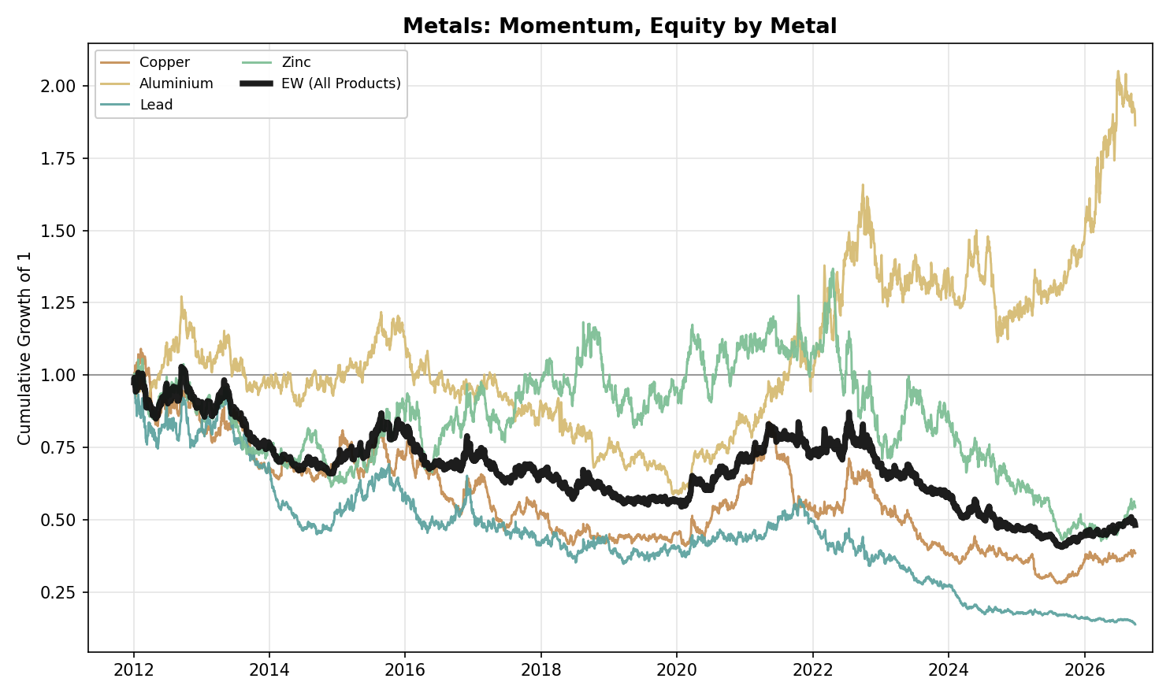
Figure A1. Metals, Momentum: Equity Curve by Metal (2012-2026)
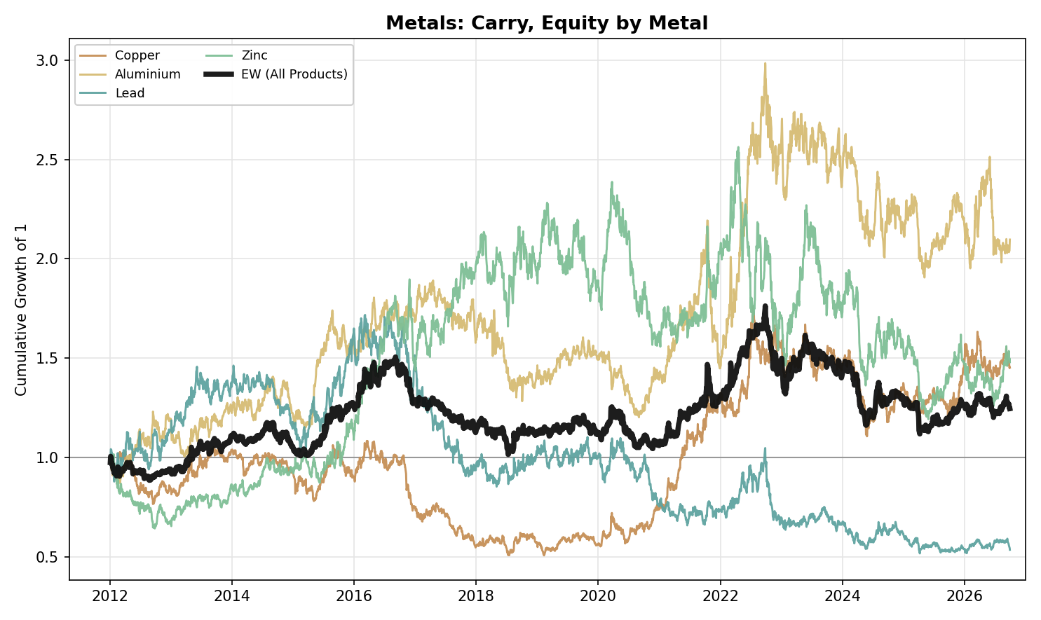
Figure A2. Metals, Carry: Equity Curve by Metal (2012-2026)
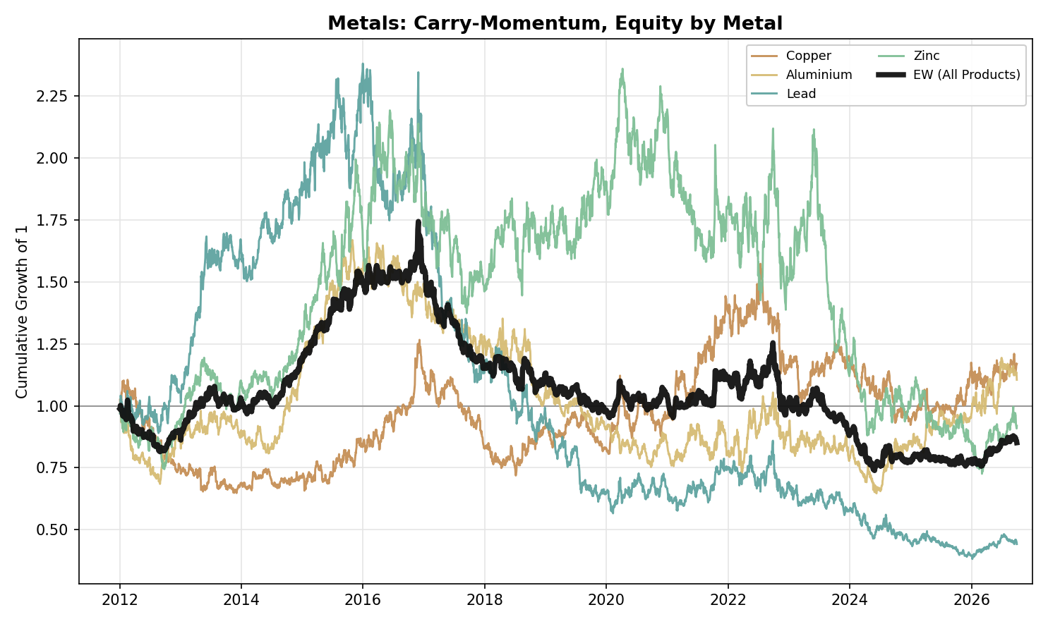
Figure A3. Metals, Carry-Momentum: Equity Curve by Metal (2012-2026)
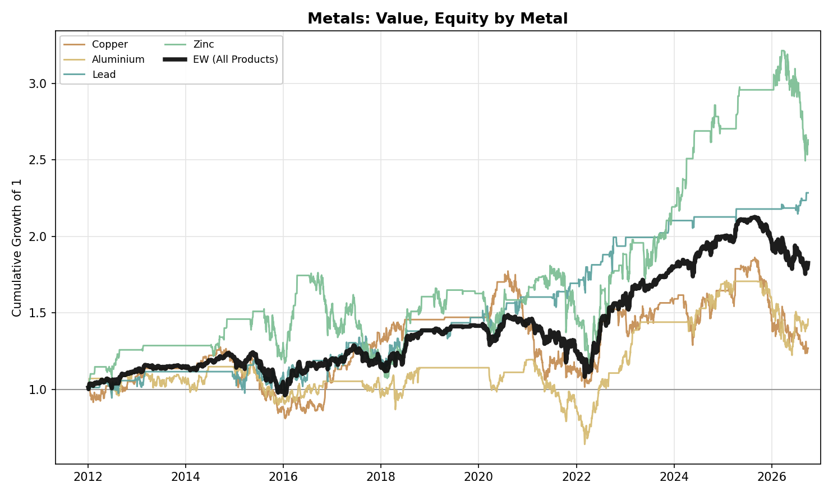
Figure A4. Metals, Value: Equity Curve by Metal (2012-2026)
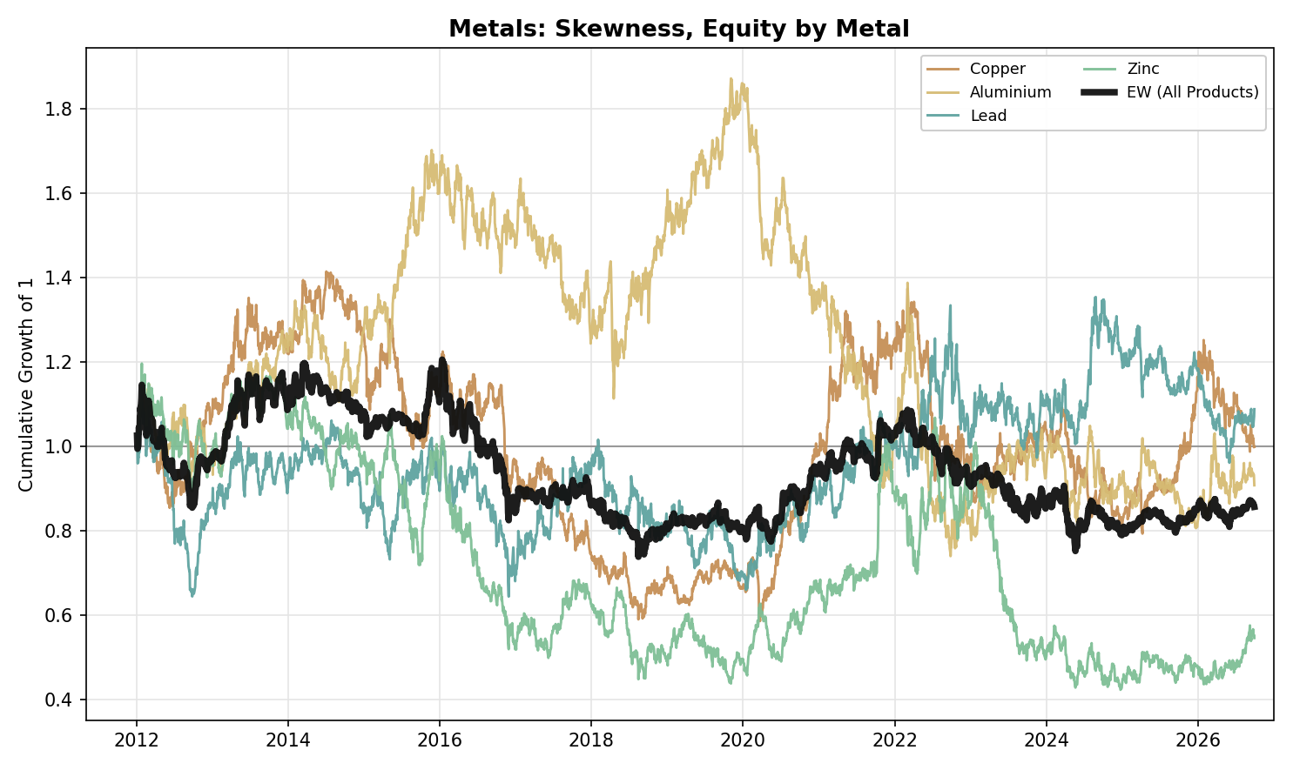
Figure A5. Metals, Skewness: Equity Curve by Metal (2012-2026)

Petroleum
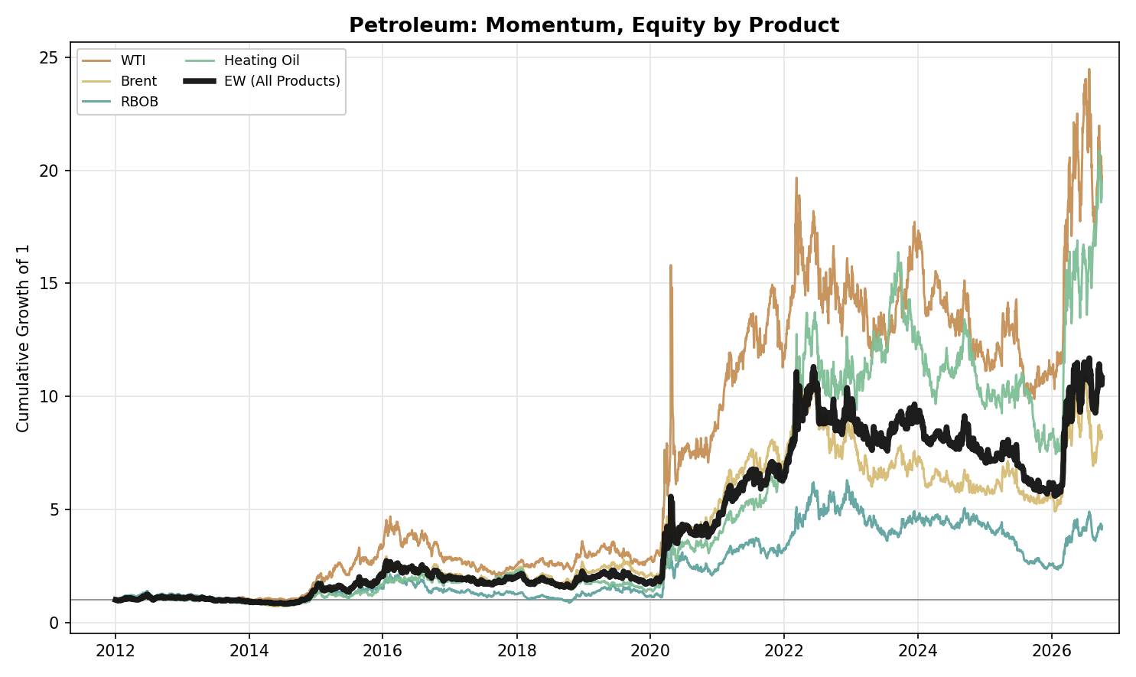
Figure A6. Petroleum, Momentum: Equity Curve by Product (2012-2026)
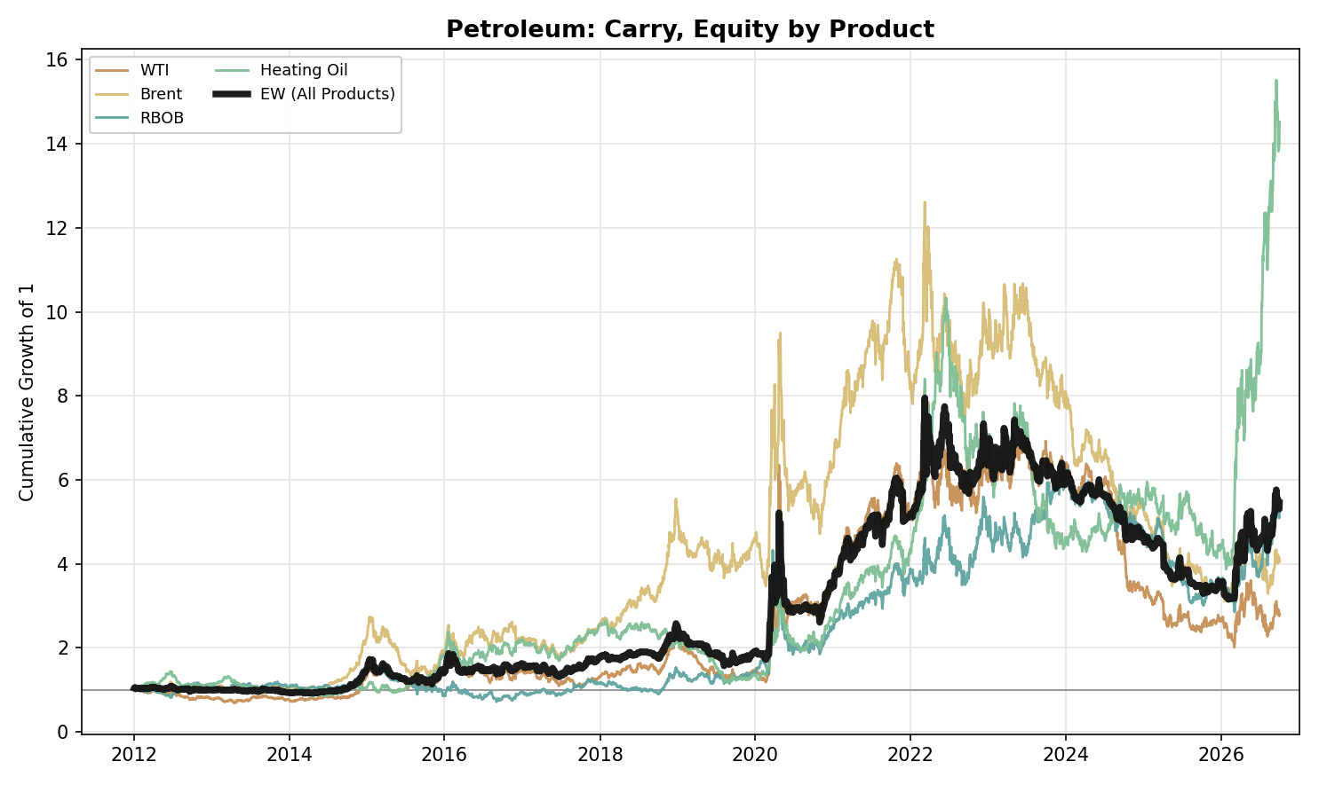
Figure A7. Petroleum, Carry: Equity Curve by Product (2012-2026)
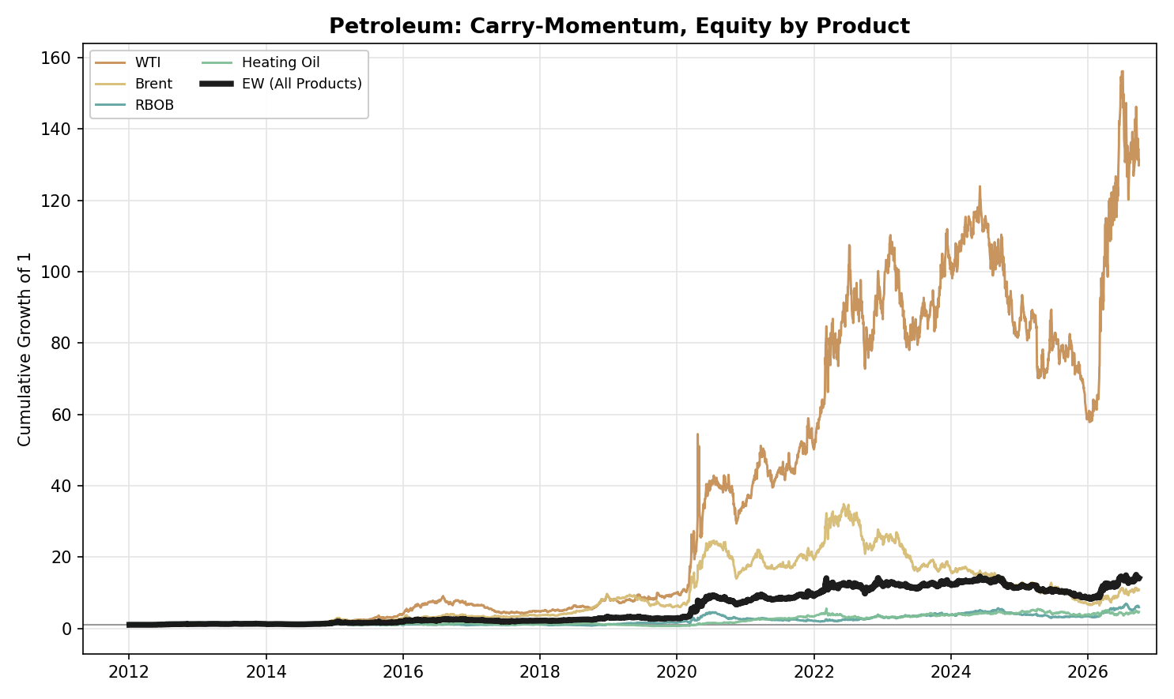
Figure A8. Petroleum, Carry-Momentum: Equity Curve by Product (2012-2026)
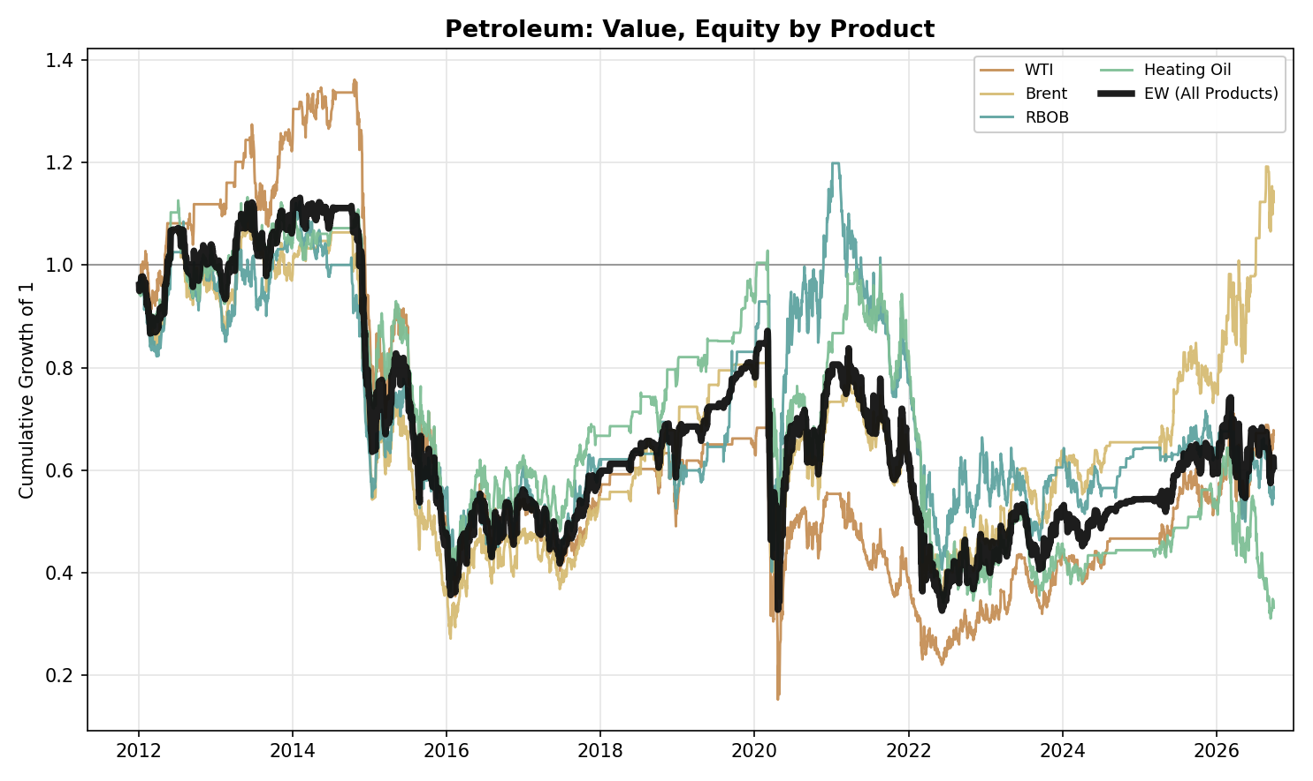
Figure A9. Petroleum, Value: Equity Curve by Product (2012-2026)
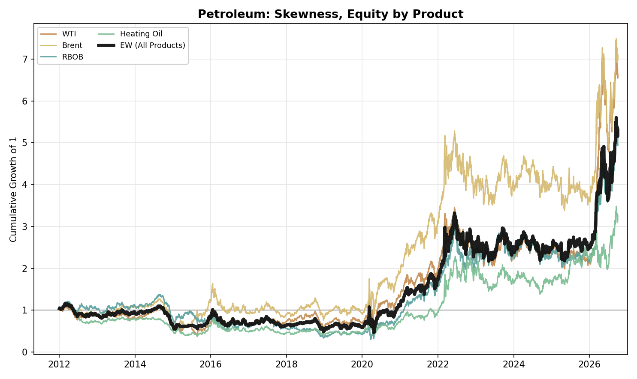
Figure A10. Petroleum, Skewness: Equity Curve by Product (2012-2026)

Precious Metals
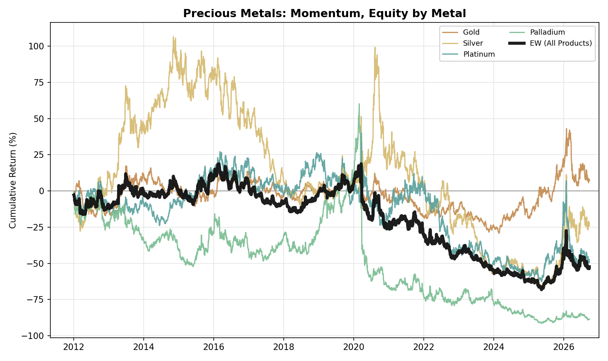
Figure A11. Precious Metals, Momentum: Equity Curve by Metal (2012-2026)
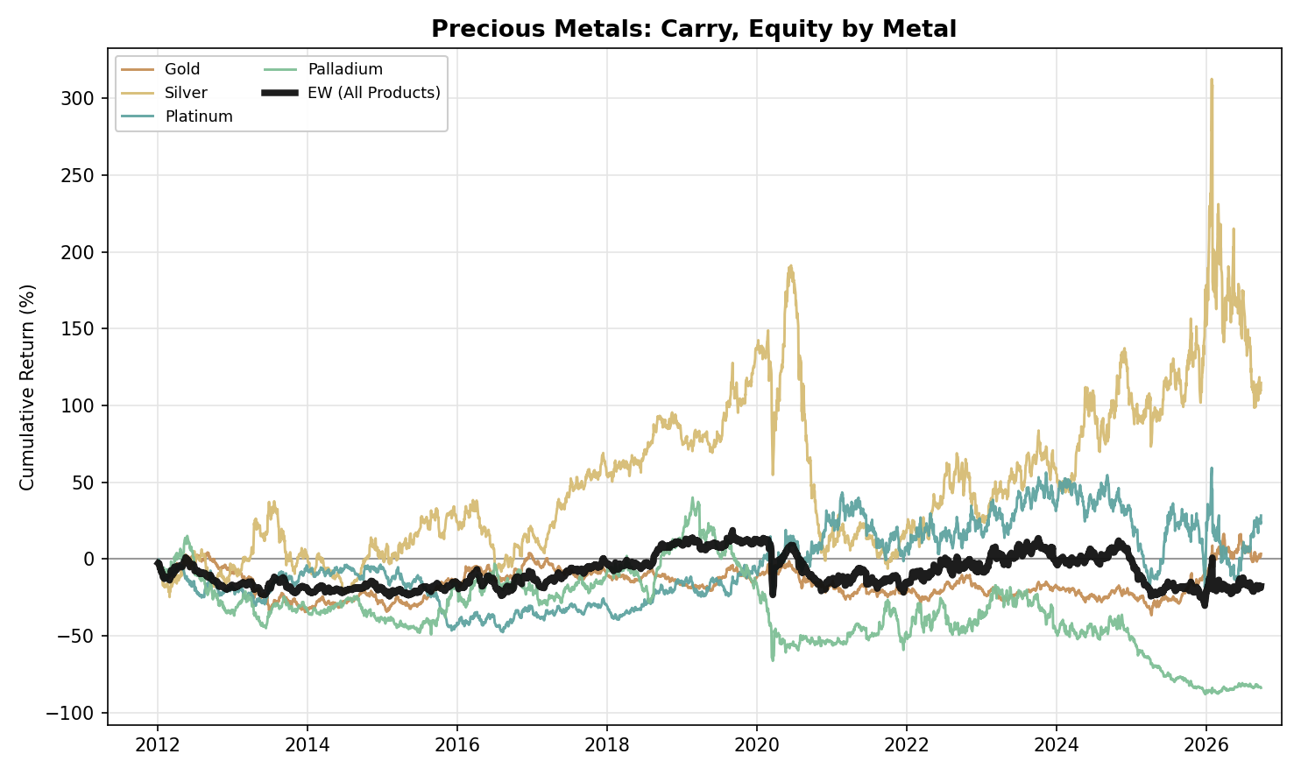
Figure A12. Precious Metals, Carry: Equity Curve by Metal (2012-2026)
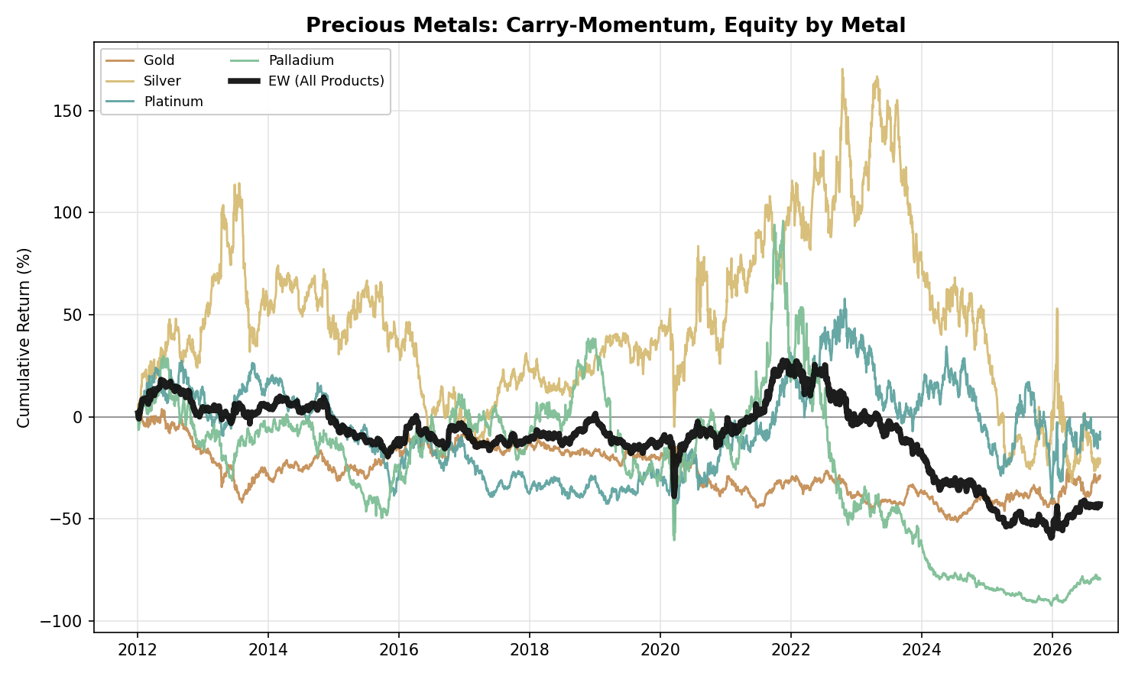
Figure A13. Precious Metals, Carry-Momentum: Equity Curve by Metal (2012-2026)
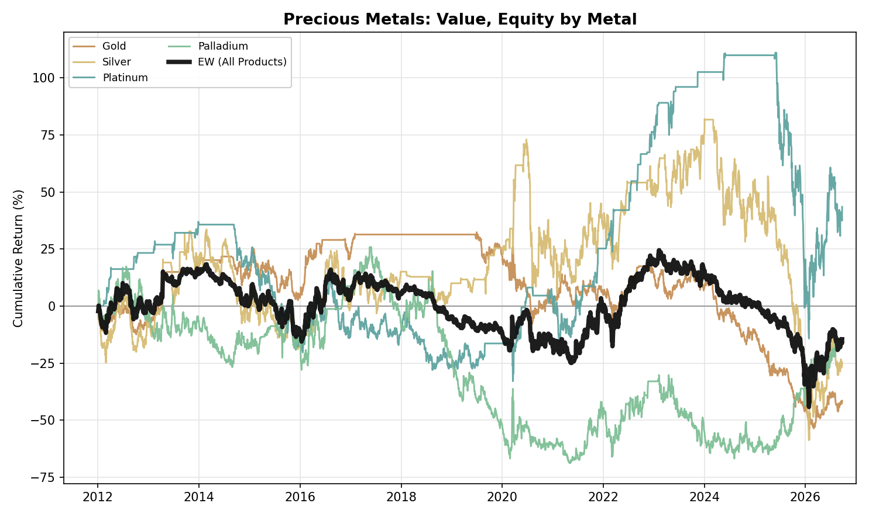
Figure A14. Precious Metals, Value: Equity Curve by Metal (2012-2026)
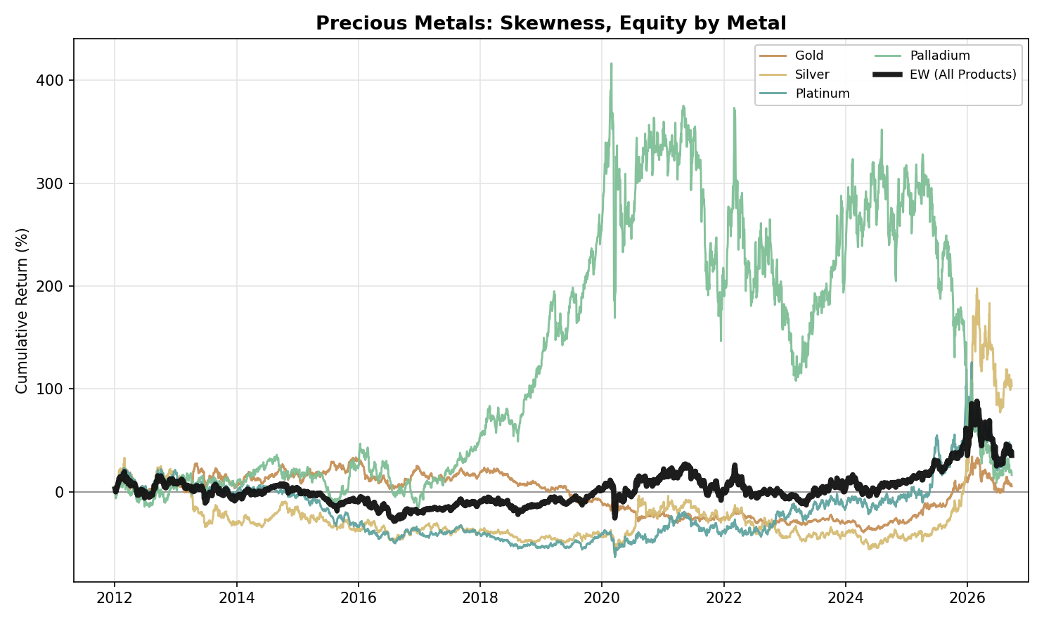
Figure A15. Precious Metals, Skewness: Equity Curve by Metal (2012-2026)

NGL
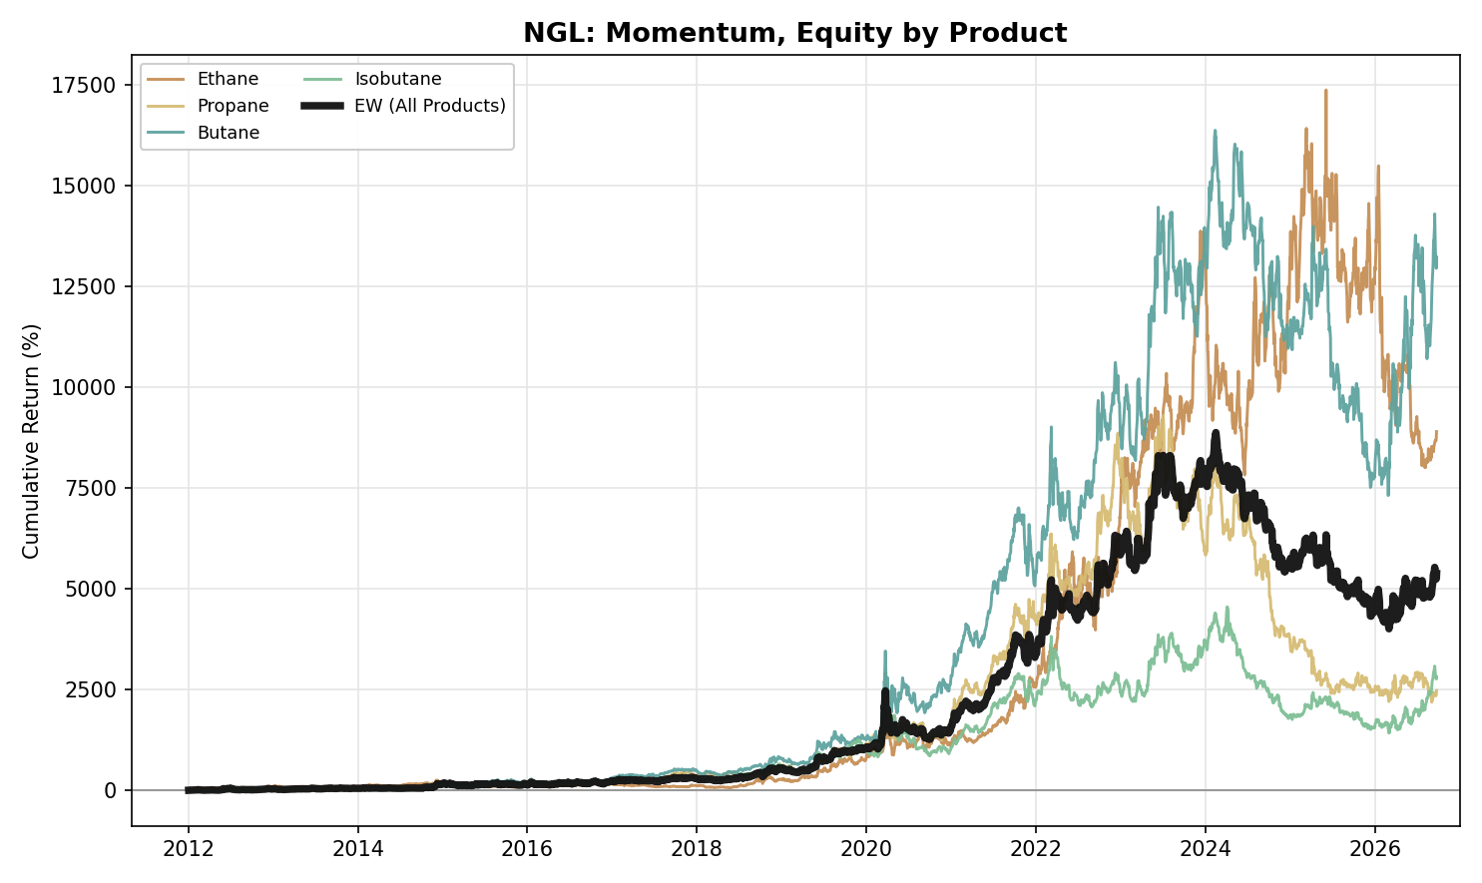
Figure A16. NGL, Momentum: Equity Curve by Product (2012-2026)
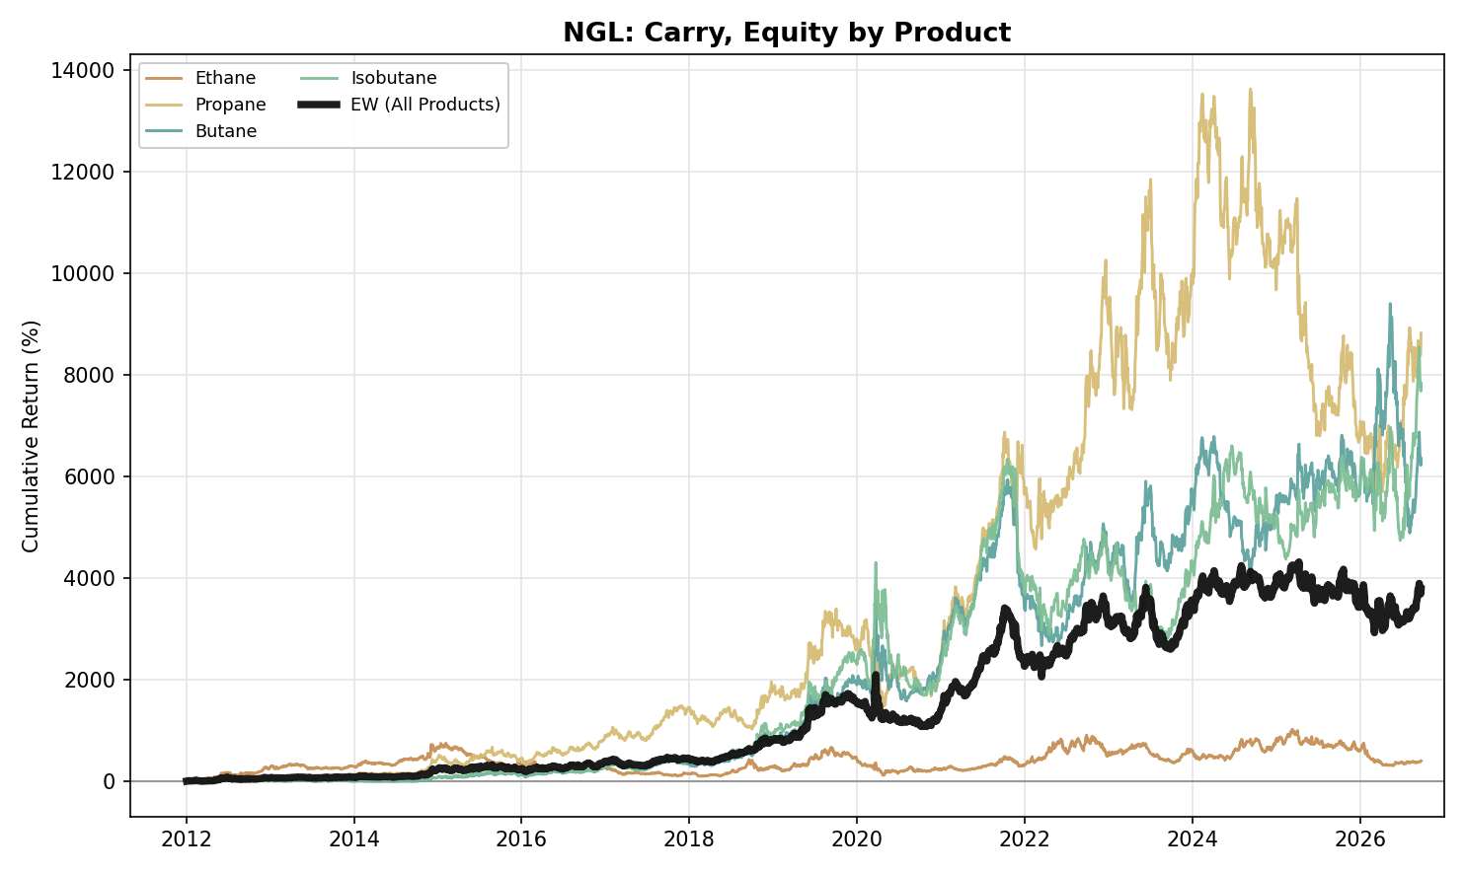
Figure A17. NGL, Carry: Equity Curve by Product (2012-2026)
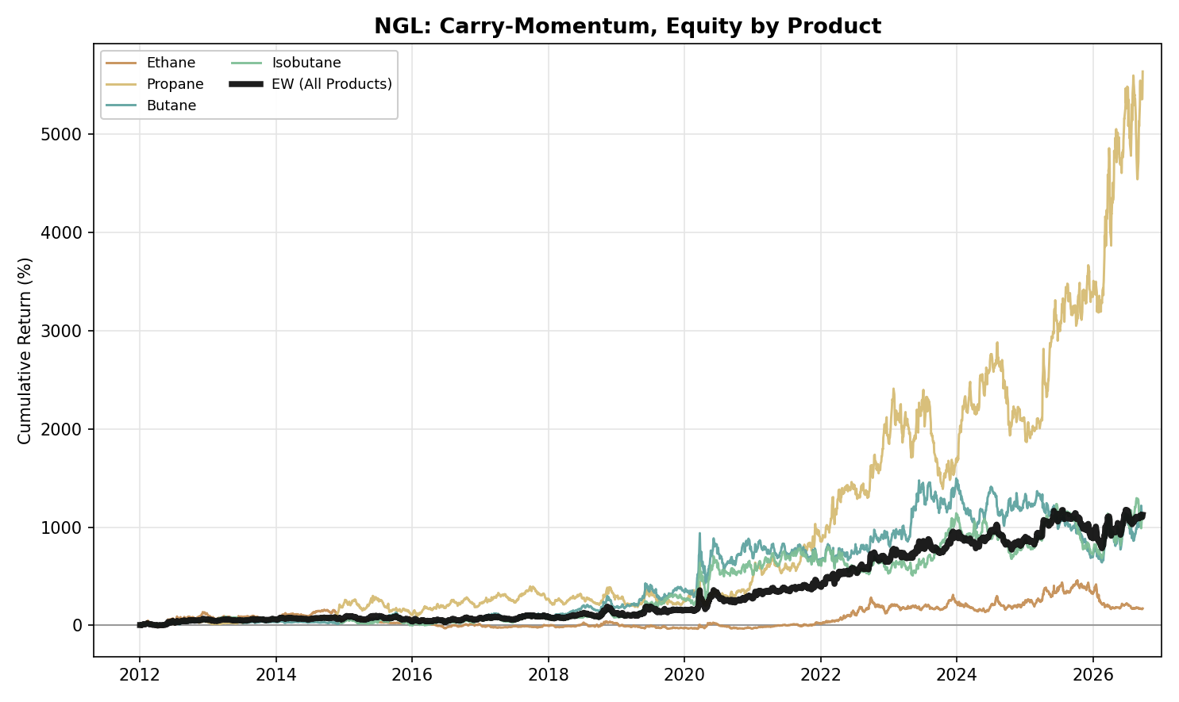
Figure A18. NGL, Carry-Momentum: Equity Curve by Product (2012-2026)
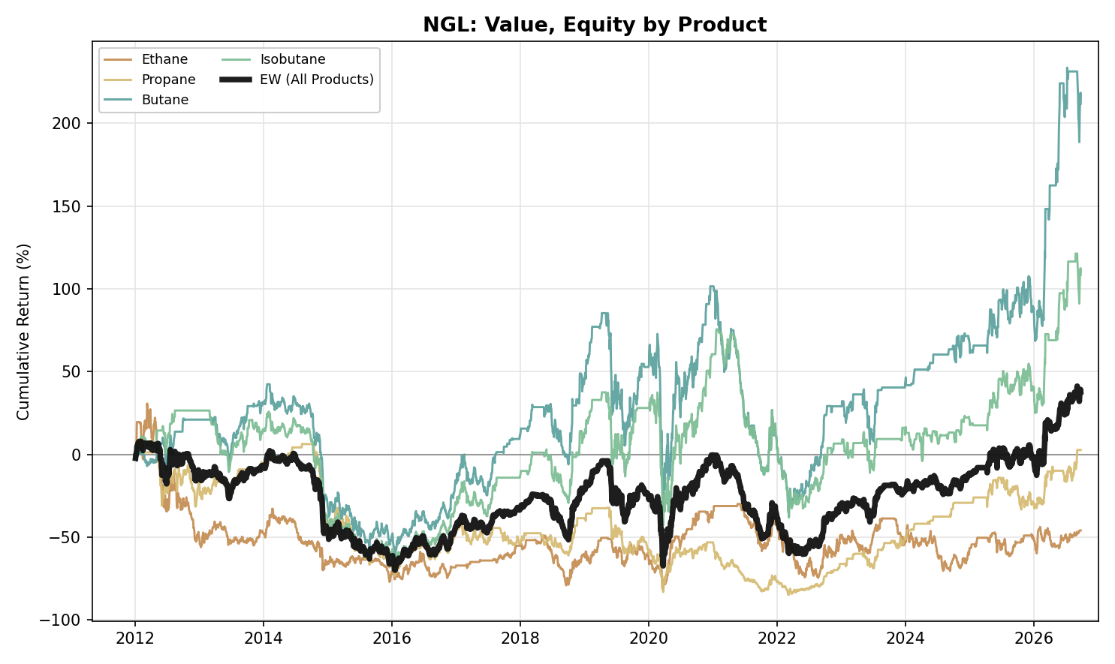
Figure A19. NGL, Value: Equity Curve by Product (2012-2026)
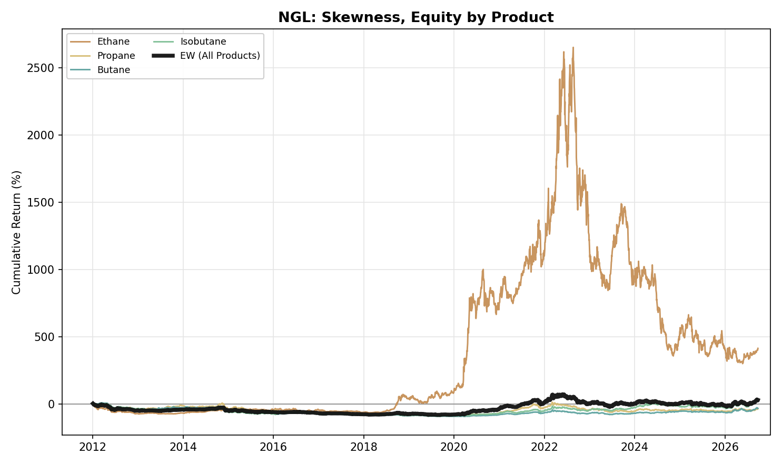
Figure A20. NGL, Skewness: Equity Curve by Product (2012-2026)

Agriculture
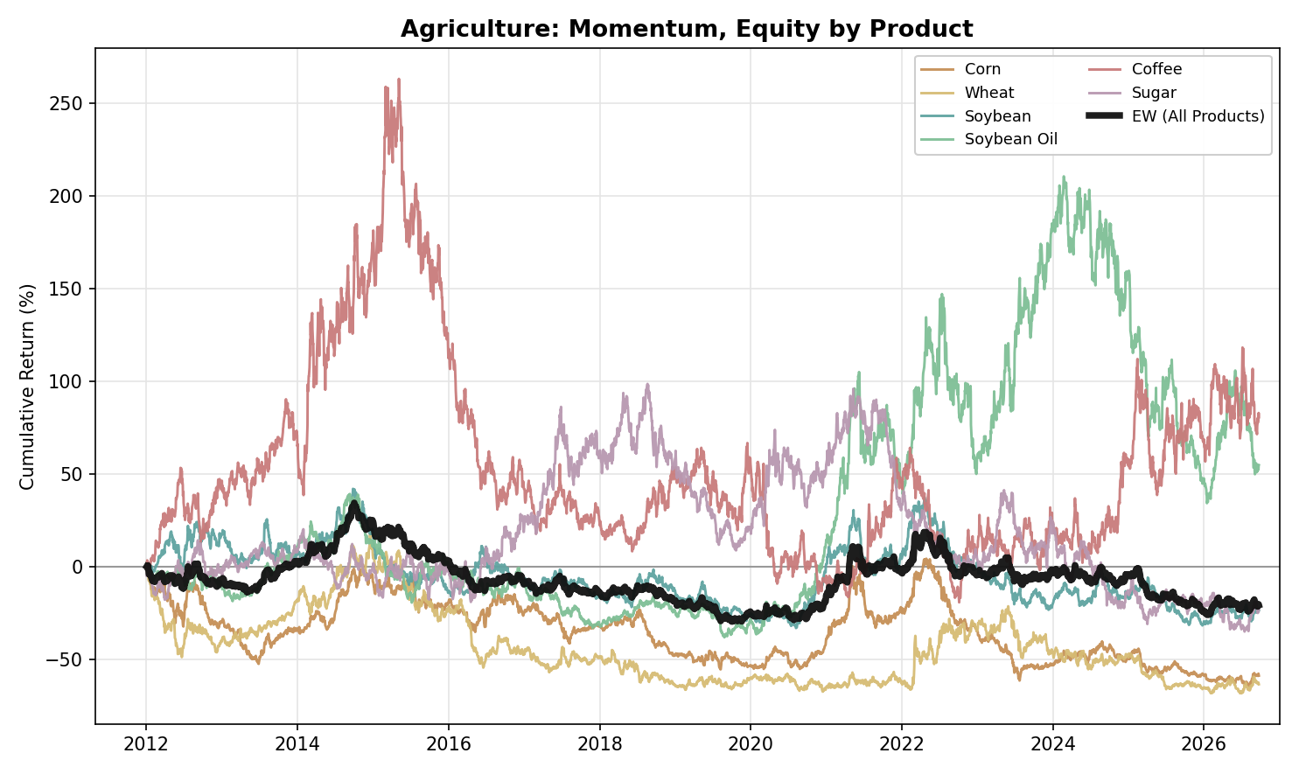
Figure A21. Agriculture, Momentum: Equity Curve by Product (2012-2026)
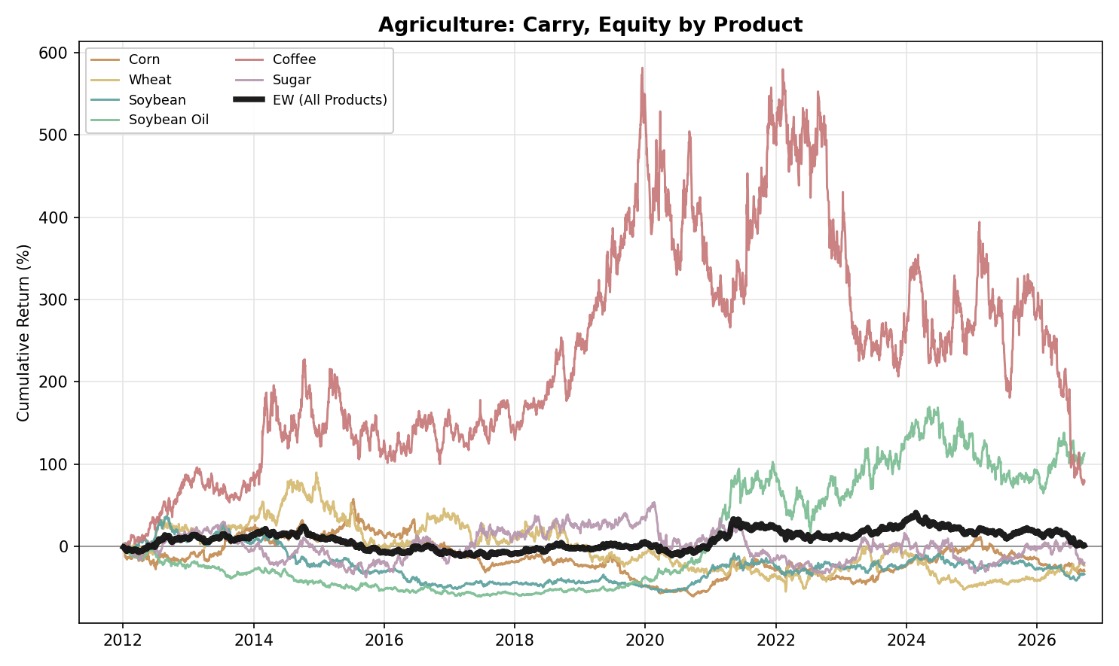
Figure A22. Agriculture, Carry: Equity Curve by Product (2012-2026)
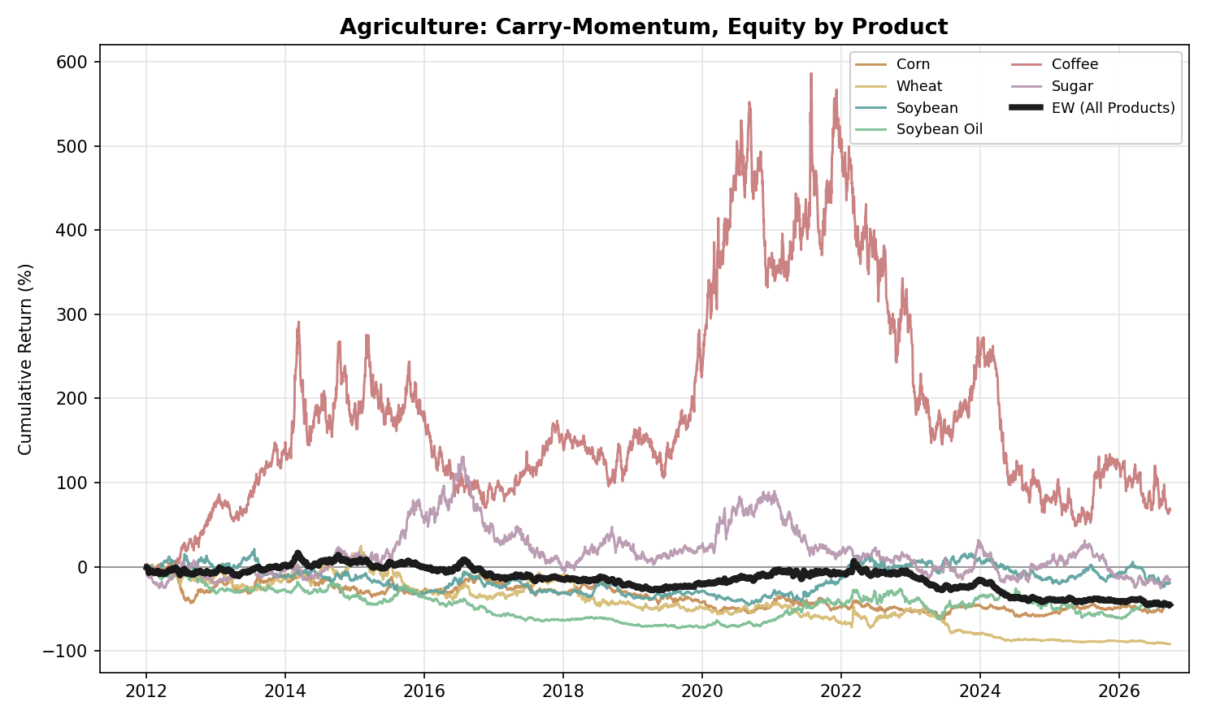
Figure A23. Agriculture, Carry-Momentum: Equity Curve by Product (2012-2026)
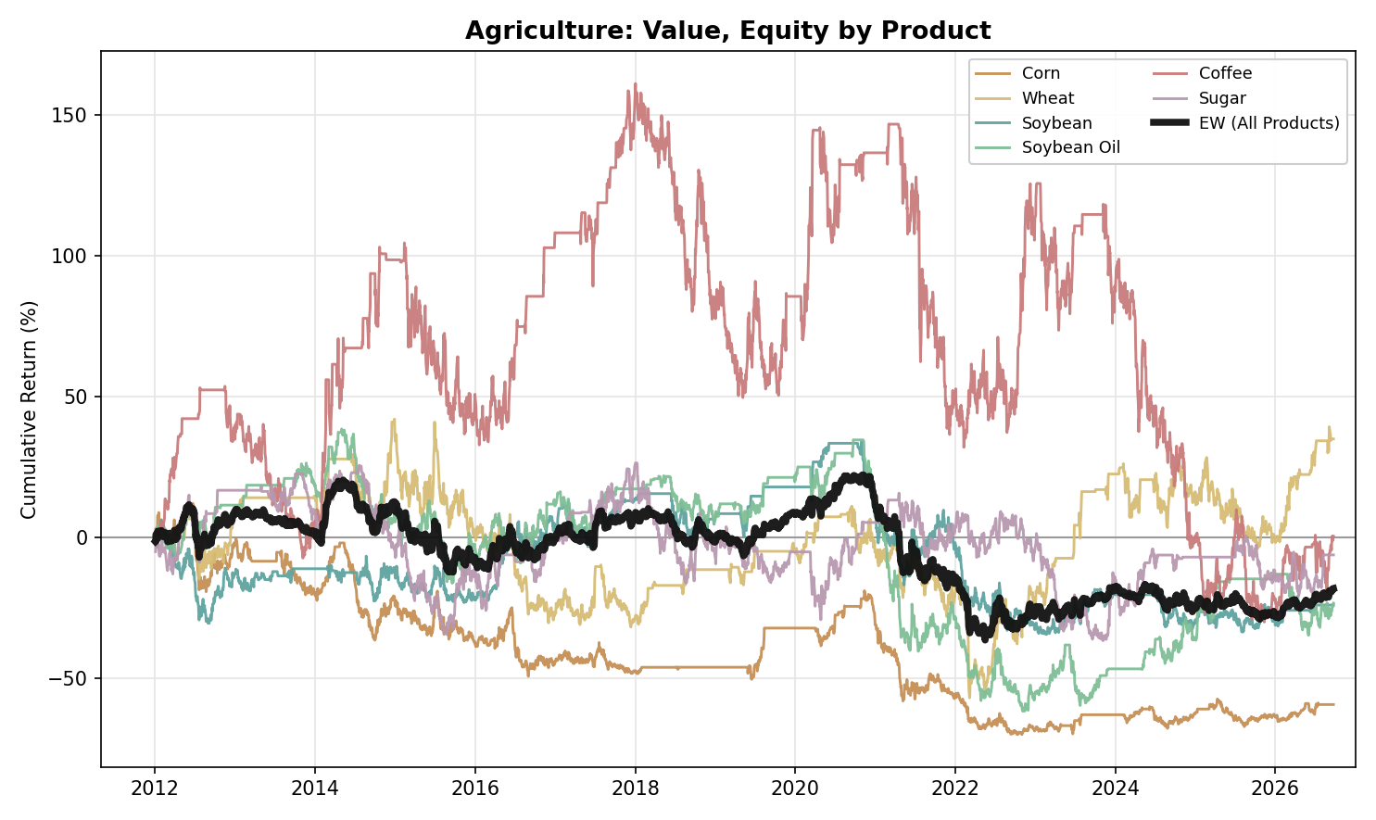
Figure A24. Agriculture, Value: Equity Curve by Product (2012-2026)
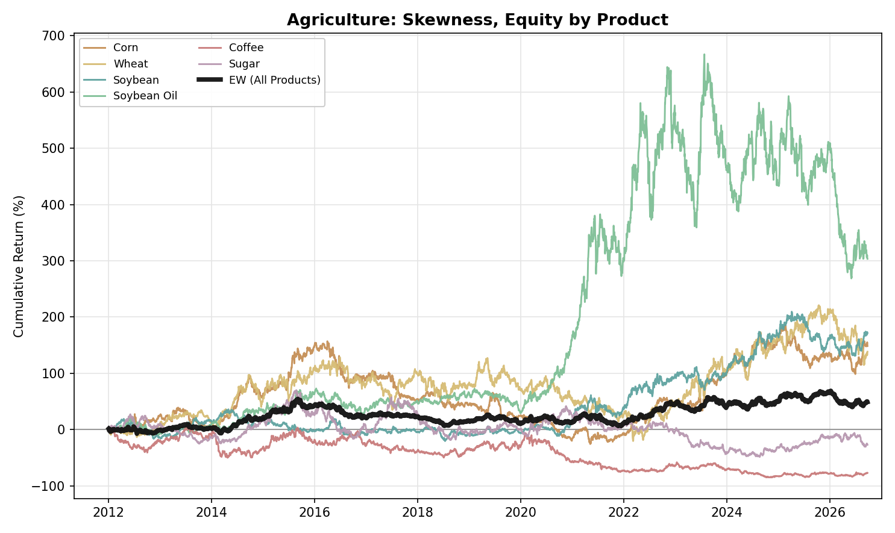
Figure A25. Agriculture, Skewness: Equity Curve by Product (2012-2026)

Cross-Pair Portfolios
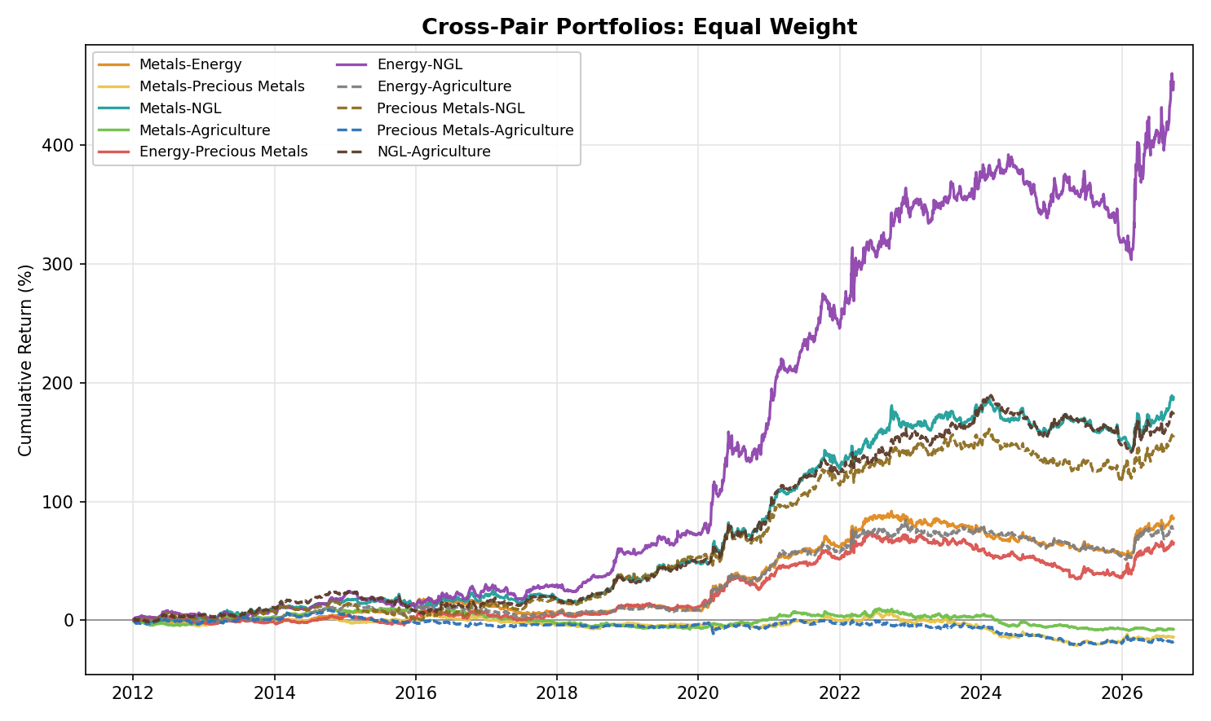
Figure A26. Cross-Pair Portfolios, Equal Weight: Equity Curve by Asset-Class Pair (2012-2026)
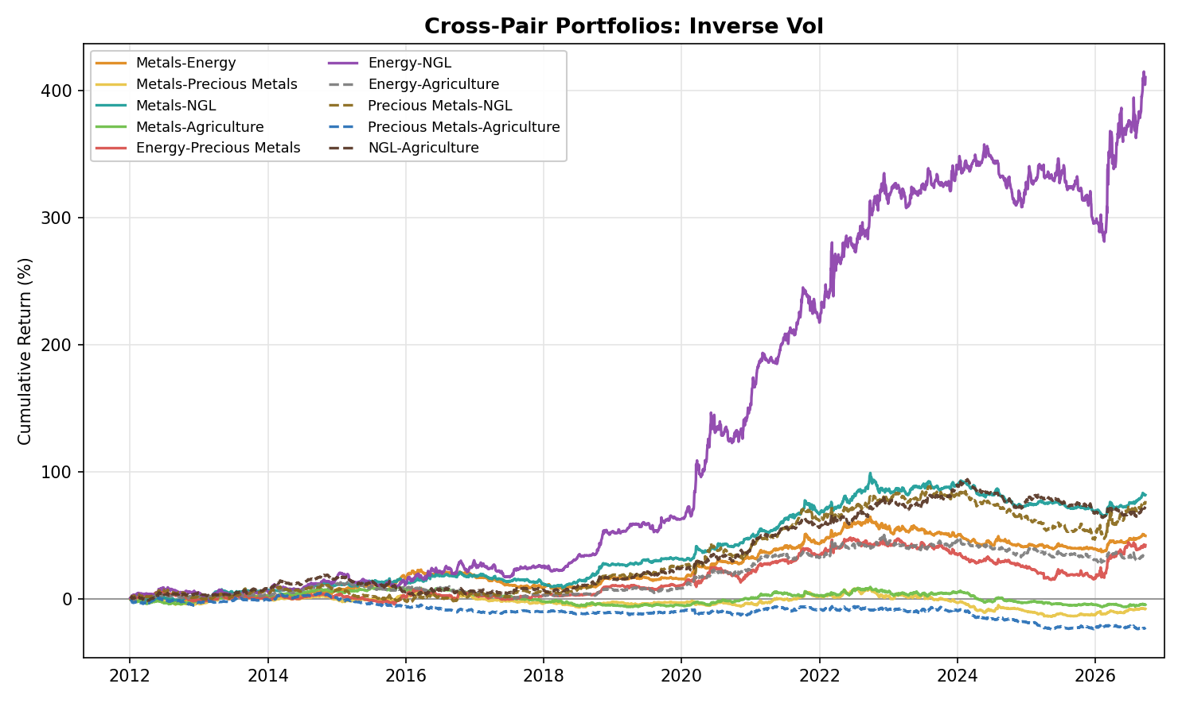
Figure A27. Cross-Pair Portfolios, Inverse Vol: Equity Curve by Asset-Class Pair (2012-2026)

Appendix: Verification Log (v3_2012 to v6)
Every figure in this document was recomputed from the per-product net returns of the pipeline in scripts/final_dashboard (rebuilt locally with the Carry rule adopted on 13 October 2026; the embedded dataset of Final_Research_Dashboard_2012.html is reproduced exactly) and cross-checked: 3,504 numbers (every asset-class tab, all 23 products, both combined books, the by-style portfolios and all Cross-Pair portfolios) were recomputed with separate code and agree with the dashboard to within 0.0005, and the Skewness sleeve agrees with Skewness_Research.html and with the Streamlit dashboards' Portfolio tabs and the hub's Cross-Asset tab. Figures are formatted from full-precision values, so a second-decimal digit can differ from the dashboard's three-decimal rounding. External facts were re-checked against sources on 13 October 2026. Statements changed or corrected in v4 and carried into v5, and the statements changed by the 13 October 2026 Carry rule, are listed below.
v6 (1 November 2026) covers the Metals and Petroleum sections only. Their per-product net returns come from the pipeline run on the data cut at 30 September 2026 (tag 0930); for every Metals and Petroleum product and sleeve they are identical to the v5 series on every date to 23 September (difference 0.0 on all 40 series, checked cell by cell including missing values), and add five trading days (24 to 30 September). The class-level statistics of the 7 series in each of the 4 windows (56 rows, four statistics each) agree with the 0930 research dashboard dataset to within 0.0005, all 15 'Return, Vol, Max Drawdown, IR' lines of the two sections and all 96 cells of Tables A1 to A6 were found in or equal to that dataset, and the within-class correlations agree with it to within 0.0005. The Skewness signal was recomputed separately from the rolled log prices (pandas skewness, identical sign on every day for all eight products) and the leg P&L reproduces under the engine's one-day execution delay; the contango averages and backwardation shares and the WTI and metals price levels were recomputed from the curve files. Every sentence-level claim in the two sections is asserted in code before the text is written, so a claim that fails stops the build. External facts were re-checked on 1 November 2026 (see the last three rows below). The rest of the document keeps the v5 verification.
Earlier statement | Treatment | Source
Copper 'record $14,851 on 22 Sep 2026' | Kept as the high of our series; market sources put the LME three-month record at about $14,800 to $14,875 on 9 to 10 Sep 2026 (sources differ by contract and time of day) | Series check; Bloomberg (record $14,802.50, reported 10 Sep), Erbakir and Discovery Alert ($14,875 on 10 Sep)
Aluminium peak '$3,876 on 4 Mar 2022' | Kept as the settlement peak of our series; LME intraday record of about $4,070 to $4,073 in March 2022 added (the exact day is not confirmed) | Series check; Harbor Aluminum, MetalCharts
WTI '$105 in June 2014' | $107 on 20 June 2014 in our series; $26 on 11 Feb 2016 | Series check
Energy Momentum 'March 2022 spike (a further 14% of the total)' | 14% is calendar 2022; March 2022 alone is 7% | Recomputed from sleeve returns
Gold 'sleeve lost 0.45 in 2025' | It is Gold's Value position (-0.45); the Precious Metals Value sleeve lost 0.31 | Recomputed
Producer hedge book '182 tonnes at end-2024' | 182 tonnes was the first WGC estimate; with the end-2025 estimate of about 120 tonnes after a fall of 74 tonnes, the implied revised end-2024 figure is about 194 tonnes. 218 tonnes in Q3 2017 confirmed | World Gold Council Gold Demand Trends Q3 2017, full-year 2024 and full-year 2025 (supply pages)
Mont Belvieu propane discount '$0.89/gal (Hydrocarbon Engineering)' | Figure confirmed; source is EIA Today in Energy (November 2015) | EIA Today in Energy, id 23612
LPG 'nearly 40% of global export supply (OPIS, 10 June 2026)' | Not confirmed as worded; replaced by about 30% of global LPG supply (Veson Nautical; Argus gives 30% of seaborne exports, Drewry 40%) and the record 3.3 million b/d of US LPG exports in April 2026 (S&P Global Commodities at Sea; Vortexa puts it at 2.8 million b/d) | Veson Nautical via Naftemporiki, Argus, S&P Global
Propane exports 'record 2.011 million b/d in November' | EIA: record 1.8 million b/d average in 2024; exports first topped 2 million b/d in November 2024; record 2.1 million b/d in April 2026 (the October 2026 EIA note also says April 2026 was the first month above 2 million b/d, which conflicts with the 2025 note, so the document states only the April 2026 record) | EIA Today in Energy, id 64724 and id 68244
Arabica 'lifted by 32% in a week' (July 2021) | +34% from 19 to 26 July 2021 in our series; highest front-month since October 2014 confirmed | Series check; Reuters, 26 July 2021
Coffee 'record $4.39/lb on 13 Feb 2025'; later 'all-time high $4.38 on 23 Oct 2025' | Our series is the front-month (March) contract, settle $4.389 on 13 Feb 2025; the most active contract set its record at about $4.30 that month (Barchart $4.2995 intraday, Reuters above $4.30). The $4.38 record of 23 Oct 2025 could not be confirmed and was removed | Series check; Barchart; Reuters
Henry Hub 2012 'mild winter, record storage' | EIA describes high, not record, storage; the text now says high storage | EIA Today in Energy, id 9490
Gold 'fell 28% in 2013' | Confirmed in our series (-28.3%); Reuters reported a 28% fall, the largest since 1981; gold ETF holdings fell about 33% | Series check; Reuters, Bloomberg
Gold/real-yield correlation, P3 '-0.25'; P3 real yield '1.61%' | -0.24 and 1.60% on FRED DFII10 data downloaded 12 Oct 2026 (end date 23 Sep 2026) | FRED
NGL F2-F4 slope '+3.8% / -1.6%' | +3.7% / -1.7% on the pooled product-days | Recomputed from curves
Page footer listed the old four regimes (R1 2011-2015 to R4 2022-2026) | Replaced by the three periods used throughout the document (P1 2012-2016, P2 2017-2021, P3 2022-2026) | Consistency fix (the same footer is in v2 and v3)
Cross-commodity benchmark correlations | Recomputed on refreshed ETF prices; unchanged four-sleeve values differ by at most 0.01 from v3 | Yahoo Finance via yfinance
v4: Carry and Carry-Momentum combine the two tenor pairs by a sign vote | Replaced on 13 October 2026 by the sign of the summed z-scores (Carry) and of the summed raw 20-observation slope changes (Carry-Momentum); the last signal is kept when a value is missing. Every Carry, Carry-Momentum, portfolio, ranking, correlation and cross-commodity figure is re-derived | Pipeline commit 446b360; reproduced locally, dataset identical, 3,504 numbers verified
v4: Energy ex-NatGas 'improves every sleeve' | No longer true: it improves Momentum, Value and Skewness but lowers Carry (+0.46 to +0.40) and Carry-Momentum (+0.78 to +0.72) | Recomputed
v4: Agriculture 'every core strategy is net negative' | Carry is now flat (+0.01); Momentum, Carry-Momentum and Value remain negative | Recomputed
v4: NGL 'Inverse Vol has the shallower drawdown' | Equal Weight now has the shallower drawdown (-20.9% against -21.5%); Inverse Vol keeps the marginally lower volatility | Recomputed
v4: Metals Carry P1 'concentrated in Aluminium and Zinc' | Aluminium, Zinc and Lead all earn it (IR +0.62, +0.36, +0.36); Copper loses (-0.29) | Recomputed; slopes from the curves
v4: negative asset-class pairs 'negative in both P2 and P3 under Equal Weight' | Negative in P3 under both constructions; P2 is close to zero or slightly positive for two of the three | Recomputed
v4: Inverse Vol pulls Precious Metals-NGL down most | NGL-Agriculture is now the pair it pulls down most (+1.02 to +0.72) | Recomputed
Cross-commodity correlation text: 'joint lowest under Equal Weight'; Value/Skewness 'because'; Carry-Momentum 'most genuinely diversifying' | Reworded: the same pair is the lowest under both constructions; interpretations stated as consistent with the results, not a test; Value and Skewness positions in Precious Metals measured (daily position correlation -0.81 in Palladium, -0.33 in Gold) | Recomputed from positions
v5: Energy section with five products (WTI, Brent, RBOB, Heating Oil, Natural Gas), plus an Energy ex-NatGas paragraph and Table A7 | Replaced by a Petroleum section (the four oil products). Natural Gas moved to the Power, Emissions and Nat Gas bucket, so the Natural Gas figures, the Energy ex-NatGas comparison and Table A7 are removed; tables after A6 are renumbered (old A8 to A26 are now A7 to A25) | ENGINE_CHANGELOG 31 October 2026 (buckets); dashboard tab Petroleum
v5: Metals and Energy charts show cumulative return in % starting at 0 | Figures 1, 2 and A1 to A10 are redrawn as the growth of 1 (geometric compounding of the daily net log returns, every curve starts at 1.0 on 3 January 2012); the other figures are unchanged | Chart code make_charts_v6.py
v5: Metals and Energy figures end on 23 September 2026 | Metals and Petroleum now end on 30 September 2026 (five more trading days). Metals changes: Momentum IR -0.32 to -0.33 (P3 -0.55 to -0.58), Carry +0.13 to +0.12 (P3 -0.05 to -0.07), Carry-Momentum -0.08 to -0.09, Value P3 +0.76 to +0.79, Skewness -0.08 to -0.09, Equal Weight -0.04 to -0.05, Inverse Vol +0.08 to +0.07; the four-sleeve portfolios -0.01 to -0.02 and +0.16 to +0.14; P3 by metal: Momentum Lead -1.15 to -1.17, Zinc -0.51 to -0.52, Copper -0.32 to -0.33, Aluminium +0.64 to +0.61; Value Lead +0.89 to +0.88, Zinc +0.71 to +0.73, Aluminium +0.58 to +0.61, Copper +0.13 to +0.15; Aluminium long on 23% to 24% of Skewness days | Recomputed; dashboard tag 0930
v5: Energy Momentum 'calendar years 2014, 2015, 2020 and 2021 account for 95%' | 95% was the five-product figure; for Petroleum these four years are 87% (2022 adds 14%, the first nine months of 2026 add 24%, previously 23%) | Recomputed from sleeve returns
v5: Energy Carry 'weakest in P3 (IR +0.20)' | Petroleum Carry is close to flat in P3 (IR +0.04; WTI -0.31, Brent -0.37, RBOB +0.21, Heating Oil +0.73), still positive in every period | Recomputed
v5: Energy Value 'negative in four of the five products'; Natural Gas decomposition and Natural Gas Skewness sentences | Petroleum Value is negative in three of the four products (-0.23 to -0.07) and flat in Brent (+0.02); the Natural Gas sentences are removed with the product | Recomputed
v5: Energy portfolios 'almost identical' (Equal Weight +0.76, Inverse Vol +0.78) | Petroleum Equal Weight +0.84 and Inverse Vol +0.89: Inverse Vol is ahead by 0.04 with slightly lower volatility and a shallower drawdown, against 0.12 in Metals; Skewness lifts Equal Weight +0.67 to +0.84 and Inverse Vol +0.71 to +0.89 | Recomputed
v5: 'the LME's first queue report, May 2014, put the longest aluminium wait at 748 days' | Not confirmed in any source found on 1 November 2026 (LME and Fastmarkets figures for 2014 range from 625 days at Detroit to queues of more than two years at Vlissingen); replaced by the confirmed statement that the Vlissingen queue peaked in 2014 at more than two years | Fastmarkets (Access World Vlissingen delisting article)
Copper 'high of our series, $14,851 on 22 September 2026' | Still the high of the series to 30 September. Market reports found on 1 November 2026 give LME three-month records of about $14,500 on 7 to 8 September and above $14,800 on 10 September (v5 sources); a later September LME record could not be confirmed | Series check; XTB and Sentisense (7 to 8 September), v5 sources
Iran war and Brent text ('the largest in the history of the oil market', IEA) | Confirmed: the IEA described the disruption as the largest supply disruption in the history of the oil market in its March 2026 report | IEA Oil Market Report, March 2026, as reported by Bloomberg and Reuters

